GOVERNMENT OF THE REPUBLIC OF UGANDA



[ST KIZITO’S TECHNICAL INSTITUTE, MADERA.]

Reports and Financial Statements
for the Year Ended 30 June 2025

Table of Contents
List of Acronyms 2
Statement of Responsibilities of the Accounting Officer 3
Commentary on the Financial Statements by the Accounting Officer 4
Commentary on the Financial Statements by the Head of Accounts 14
Statement of Financial Performance for the Financial Year Ended 30 June 2025 14
Statement of Financial Position as at 30 June 2025 16
Statement of Changes in Net Assets/Equity for the Financial Year ended 30 June 2025 16
Cash flow Statement 17
Statement of Appropriation based on Classification of Expenditure by Nature 19
Statement of Appropriation based on the Classification of Expenses by Programmes Error! Bookmark not defined.
Reconciliation between total expenditure per Appropriation Accounts and per Statement of Financial Performance 20
Notes to the Financial Statements 21
Note 1(a): Accounting Policies 21
Other Notes to the Financial Statements 29
Statement of Performance 39
Statement of Revenues collected during the year 40
Statement of Arrears of Revenues [Based on source of revenue per category] 41
Statement of contingent liabilities and guarantees 42
Statement of non-quantifiable contingent liabilities 43
Statement of Outstanding Commitments 44
Statement of losses of public money and stores written off, and claims abandoned during the year 45
Statement of reported losses of public moneys, stores and other assets whether or not written off during the year 46
Summary statement of stores and other assets (physical assets) as at the end of the year 47
Schedule of Project and Subvention Balances 49
Schedule of Letters of Credit 50
Annexes to the Financial Statements 51
Annex i: Asset Categories and their useful lives 51
Annex (ii): Trial Balance 53
Annex (iii): Bank Reconciliations and list of all bank accounts 53
Annex (iv): Schedule of Verified Arrears 53

List of Acronyms

Statement of Responsibilities of the Accounting Officer
The financial statements set out on pages 2 to 69. have been prepared in compliance with the provisions of the Public Finance Management Act, 2015 Cap 171 (the Act) and the generally accepted accounting principles for the public sector. They have been prepared on the modified accrual basis of accounting where revenue is recognized when earned with the exception of taxes and grants which are recognized when received. Expenditure on the other hand is recognized when incurred, as further detailed in the accounting policies that are part of these financial statements.

In accordance with the provisions of Section 43 and Schedule 5 of the Act, I am responsible for and personally accountable to Parliament for the activities of the vote to which I am the accounting officer. Further, I am responsible for the regularity and proper use of the money appropriated to the vote to which I am the Accounting Officer. I am also responsible for authorizing any commitments made by the vote and for controlling resources received, held or disposed of by or on account of the vote. Finally, I am responsible for putting in place effective systems of risk management and internal control in respect to all resources and transactions of the vote.

Section 43 (3) of the Act requires the Accounting Officer to enter into an annual budget performance contract with the Secretary to the Treasury which shall bind the Accounting Officer to deliver on the activities in the work plan of the vote for a financial year.

Sections 48 and 49 of the Act require me to prepare and submit financial statements of my vote to the Accountant General for consolidation and to the Auditor General for audit within the timelines specified in the Act using the prescribed formats.

Accordingly, I am pleased to report that I have complied with these provisions in all material respects, and I am also pleased to submit the required financial statements in compliance with the Act. I have provided and will continue to provide, all the information and explanations that may be required in relation to these financial statements.

To the best of my knowledge and belief, these financial statements are consistent with the books of account, which have been accurately maintained.

I accept responsibility for the integrity and objectivity of these financial statements, the financial information they contain, and their compliance with the Act, as amended.

…………………………………………………………………………………………….
Accounting Officer [Names and Signature]

…………………………….
Date

Commentary on the Financial Statements by the Accounting Officer
General Information about the Reporting Entity
St Kizitos Technical Institute is a government aided institution that was founded by catholic church in 1947.The Institute offers holistic technical Education based on Christian Principals while upholding good Morals and Co-curricular activities.
Please provide the following information within a maximum of a three (3) page commentary!

Principal Activity of the Vote
The Institute) is mandated under the provision pf the Public Finance and management ACT 2015 amended constitution of the republic of Uganda 1995, The mandate is to offer Technical Education to the population.
Structurally the Chairperson Board of governors is the Overseer of the Institute activities, assisted by the Board members, to monitor the general administration and oversee the implementation of policies and decisions made by the Board of Governors.
The principal is the accounting officer who supervises and coordinates the overall learning process and environment at the Institute.

VISION:
To be a center of excellence in Skills and Moral Training

MISSION:
To produce competent and Committed individuals for the world of work
CORE VALUES
- Fear of God
- Responsibility
- Excellence
- Equality
- Discipline
COURSES OFFERED
The Institute, offers the following courses
- National Certificate in Building Construction
- National Certificate in Automotive Mechanics
- National Certificate in Wood Work Technology
- National Certificate in Fashion and Garment Design
- National Certificate in Machining and Fitting
- National Certificate in Plumbing
- National Certificate in Electrical Installation systems
Key Performance highlights
During the reporting period, the vote undertook the following major activities besides recurrent expenditure)
- Drilled the Borehole at the Institute and Installation of the borehole.
- Renovation of Fr Wankya Dormitory.
- Renovated 4 classroom block roof at the old site
- Installed CCTV Cameras
- Renovation works at the old site Lubiri Girls Dormitory ongoing
- Making Concrete Blocks on going for fencing the Institute.
- Sinking of a 3 Stance Pit Latrine at the Old Site for boys
- Sinking of A pit latrine at the old site Lubiri Dormitory for girls

Renovation of a Dormitory and classroom block

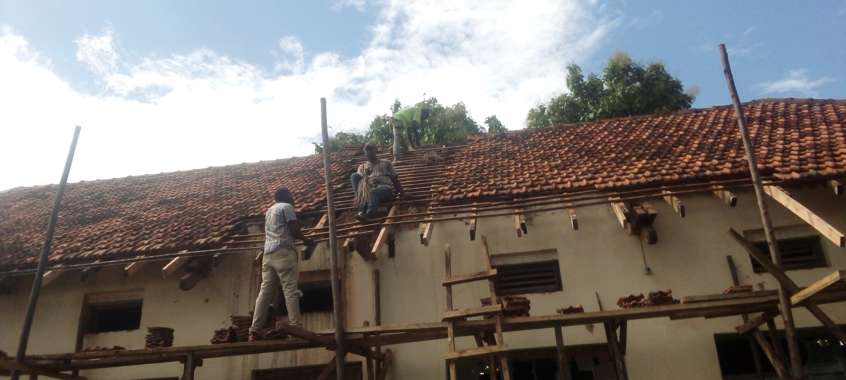 | 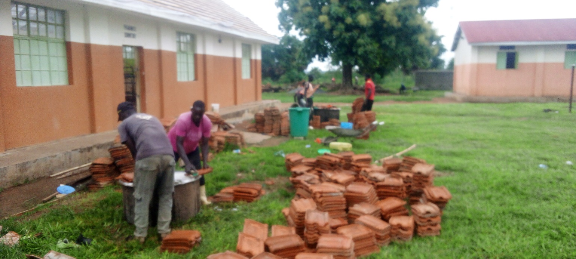
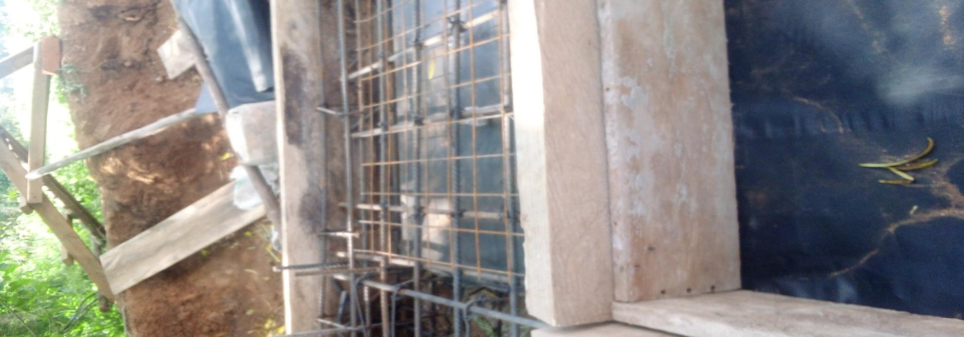 | 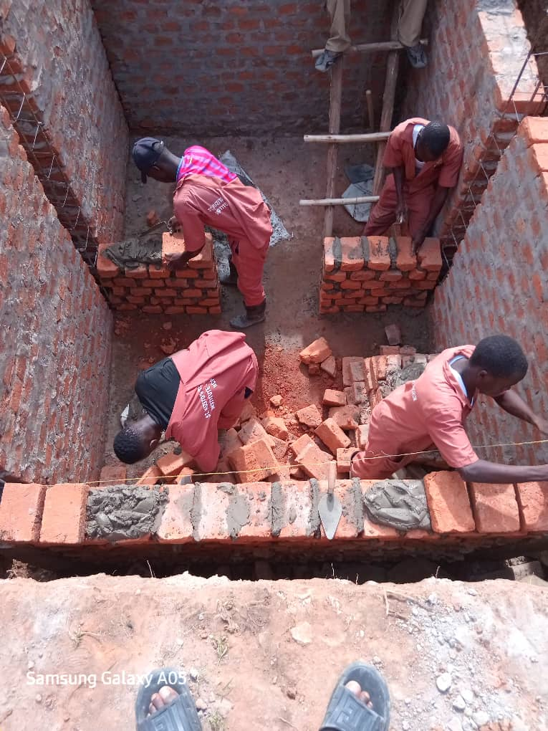
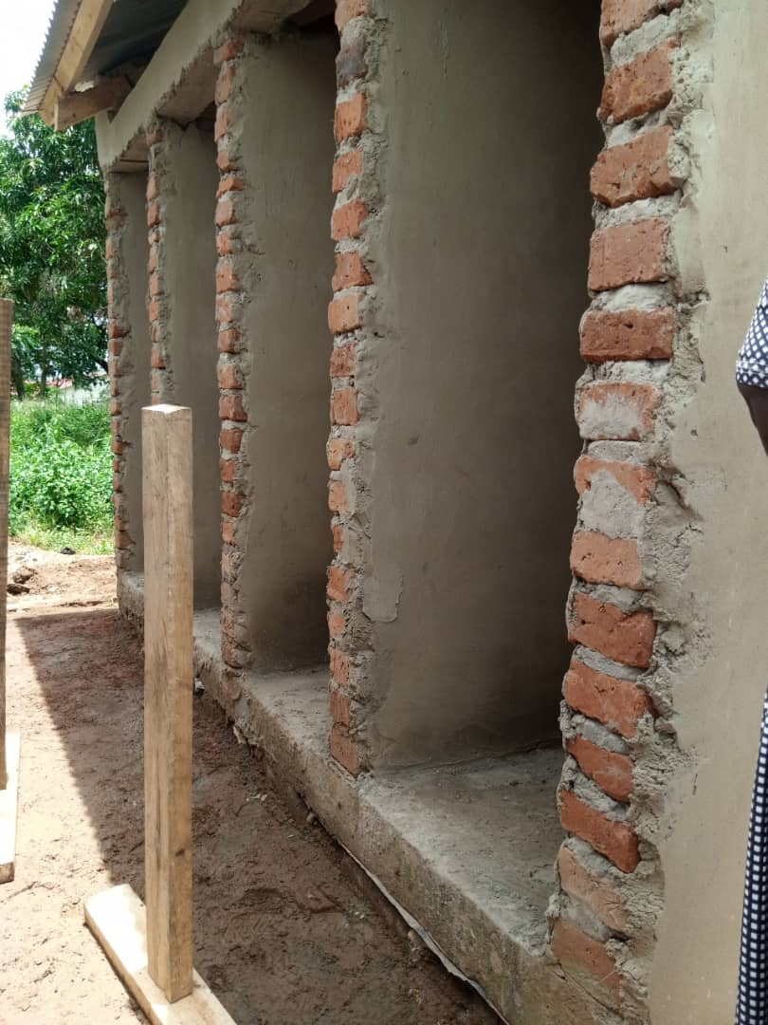 | 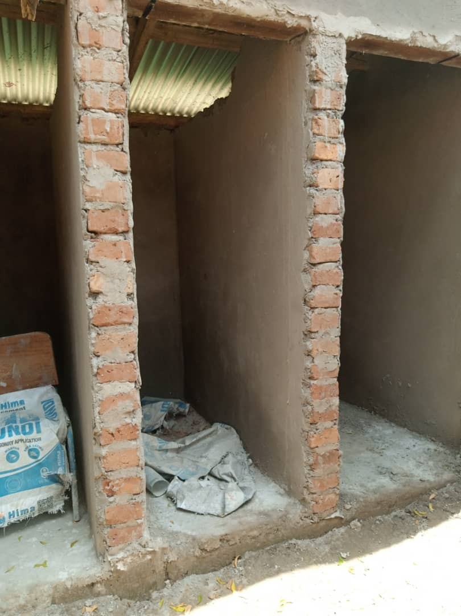
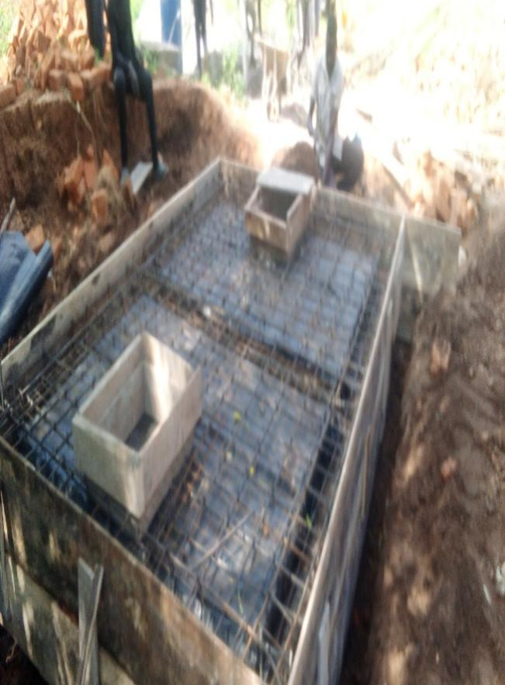 | 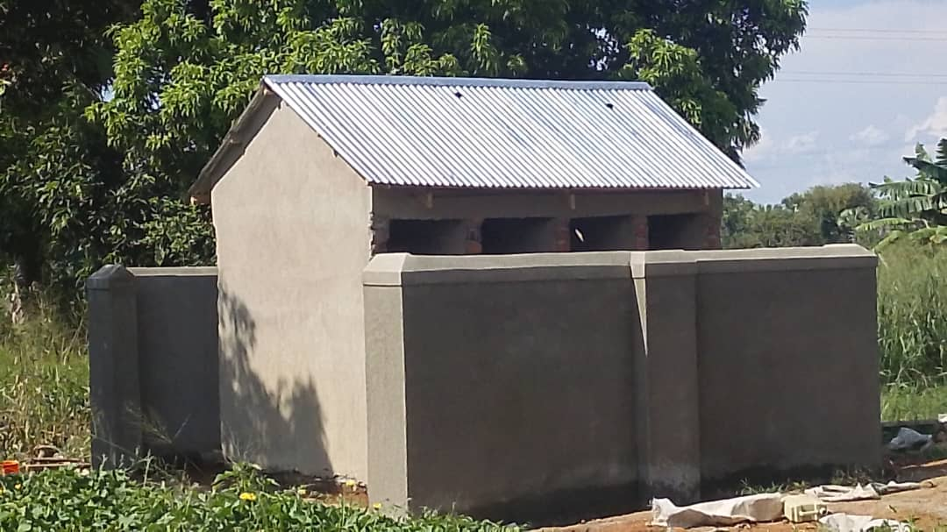
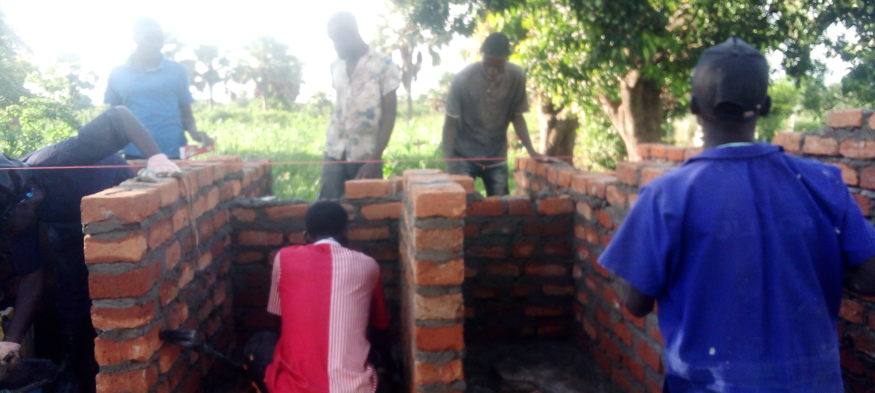 | 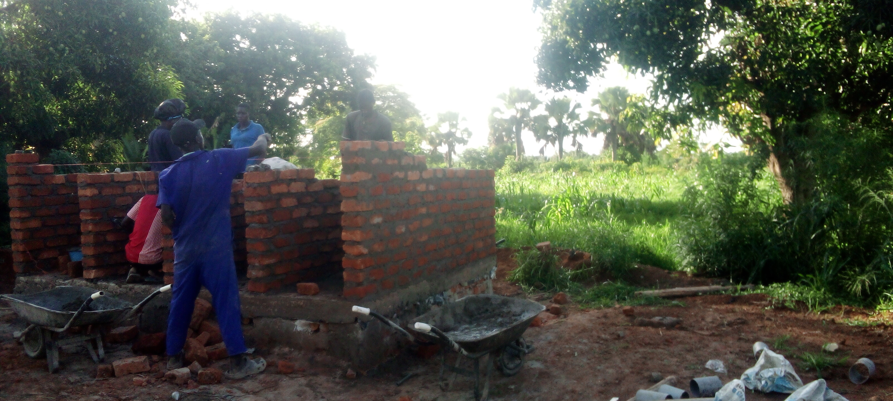

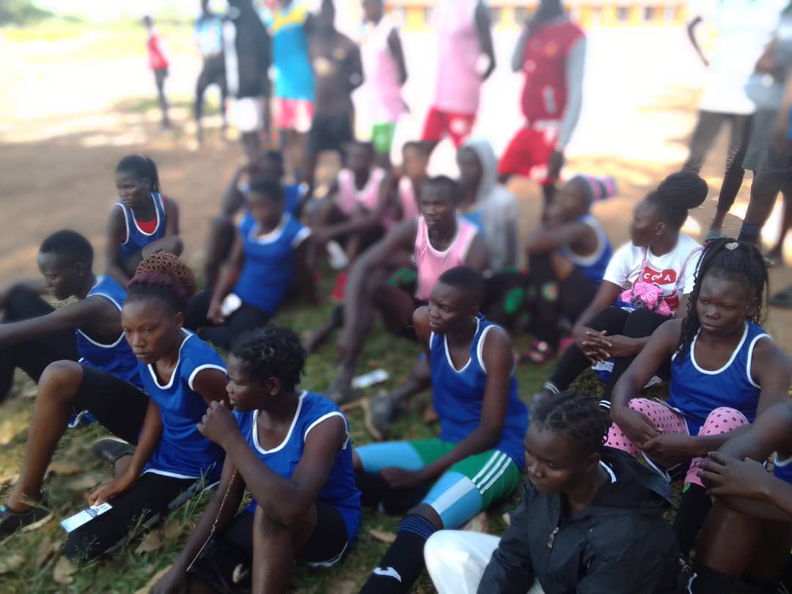

Risk Management Practice and Internal Control
The vote maintained a system of internal control through the following
- The Board of Governors is responsible for the management of all Institutes Property Including all funds generated and due to the Institute. It also supervises and controls all matters relating to financial affairs of the Institute.
- The funds are sent to the Institute through Soroti District Local Government; therefore, we are being guided by the Chief administrative officer who is the overall supervisor.
- The principal is the accounting officer and is responsible for the establishment of Internal Controls that is designed to provide assurance that the transactions recorded are within the authority and all financial transactions are captured correctly and posted to the relevant books of accounts
- We make sure that no cash is received at source. All funds must be banked intact.
- The School Pay system has given us a big relief.
- The Internal Control system has operated smoothly throughout the financial year ended June 2025
- More temporal staff have continuously been recruited to bridge the gaps not filled and those created by the retired staff hence reducing the possible available risks
Report on achievements of the audit
The Audit Generally has been very Good and Helpful so much so that our financial Statements are up-to date and more so a reminder to all persons holding Public offices to always follow the set rules and regulations of the Management of Government funds and resources.
Payroll and Pensions Management
- Salary is paid at the Center under Government of Uganda for the staff appointed by the Ministry of Education and sports.
- For staff appointed by the Board of Governors, they are paid through the school fees paid by the parents with a budget line allocated to it in the approved budget for the year under review.
Asset Management
St Kizito’s Technical Institute, Madera has land that was given by the Catholic church and a variety of buildings. Later on, the Government under ADB11 Constructed new structures and equipped them and handed to the Institute.
The Institute also received a donation of Vehicles and motorcycles for practical purposes.
Action(s) taken on recommendations of oversight institutions
During the year the Board of survey did its work and made recommendations for action but since the Institute is practical oriented most of the assets like motorcycles and old vehicles are for trading purposes.

Accounting Officer [Names and Signature]

…………………………….
Date

Commentary on the Financial Statements by the Head of Accounts
Give a maximum of a three-page commentary on financial performance and financial position of the vote covering a trend analysis in comparison to previous year’s performance.
- Commentary on the Income and Expenditure of the vote against budget
In the year under review the Institute had a total anticipated revenue of 1,231,886,860. however, at the end of the year the Institute was able to collect1,144,235,244
- Comment on the Assets and Liabilities of the vote and mention any significant acquisition or disposal of asset as well as liability incurred or settled during the reporting period. The Assets acquired during the period include, Bore hole, installation of CCTV CAMERAS
The Institute was able to pay its outstanding commitments totaling to 58,411,375. That was majorly for Consumables
- During the period the institute paid of 58,411,375,
- Comment on the going concern status of the vote [ Especially for the votes that are under Rationalization]
Currently we are appointed by the Education Service commission under Ministry of Education, and that is where we fall.
- Comment on any multiyear commitments and outstanding obligations by year end
At the end of the year the outstanding commitments totaled to 59,215,130
- Comment(s)/ explanatory notes on any adjustments made in the Statement of Changes in Equity or Reconciliation of movement of cash during the year if any [Explain the cause of the adjustments i.e whether they are as a result of a change in the accounting policy, changes in estimates or as a result of errors and or omissions]
The adjustments were made as a result of the new format of making financial statements that involved Depreciation.
- Departure from accounting principles or practice and justification if any
Previously we were on cash accounting but now we are on modified cash accrual accounting. This is because we are taken as a tertiary Institution much as we enroll students who have completed form four and those who have Junior Certificate in Technical Education
- Any other information that is deemed relevant by the Head of Accounts
The Accountant Generals office should at least organize for capacity training workshop to a quant the Senior Assistant accountants with new formats of making financial statements

I take full responsibility for the completeness and integrity of these Financial Statements

…………………………………………………………………………………………….
Head of Accounts [Names and Signature]

…………………………….
Date

Statement of Financial Performance for the Financial Year Ended 30 June 2025
[Based on classification of expenditures by nature]
 | Notes | Actual  30 June 2025  (Shs) | Actual  30 June 2024  (Shs)
REVENUE
Revenue from non-Exchange transactions
Taxes | 2 | 0 | -
External Assistance | 3 | 0 | -
Transfers received from Treasury- UCF | 4 | 167,921,378 | 243,333,407
Transfers received from the Contingencies Fund | 5 | 0 | -
Transfers received from other Government Units | 6 | 12,200,000 | 43,777,500
Non-Tax revenue- Exchange Transaction | 7 | 0 | -
Sub-total Revenue from Exchange transactions | 8 | 931,713,866 | 1,143,042,000
Revenue in kind | 8(b) | 31,100,000 | 19,800,000
Non-Tax Revenue- Exchange |  | 1,300,000 | -
Sub-total Revenue from exchange transactions |  | 0 | -
Total Revenue |  | 1,144,235,244 | 1,449,952,907
EXPENSES
Compensation of employees | 9 | 110,484,800 | 180,120,500
Goods and services consumed | 10 | 729,291,687, | 904,259,070
Depreciation expense | 11 | 3,708,438 | 0
Impairment of property, plant, and equipment | 12 | 0 | 0
Subsidies | 13 | 0 | 0
Grants and other transfers | 14 | 0 | 0
Social benefits | 15 | 0 | 0
Finance costs | 16 | 0 | 0
Bad debts expense | 17 | 0 | 0
Other expenses | 18 | 275,579,176 | 346,408,159
Total Expenses |  | 1,119,064,101 | 1,430,787,456
Foreign Exchange gains/loss | 19 | - | -
Transfers to Treasury | 20 | - | -
Gain/ loss on asset revaluation | 32 | - | -
Surplus/ Deficit for the year |  | 25,171,143 | 19,165,451

…………………………………………………………………………………………………
Accounting Officer [Names & Signature]

Statement of Financial Position as at 30 June 2025
 | Notes | 30 June 2025  (Shs) | 30 June 2024  (Shs)
ASSETS
Current Assets
Cash and Cash equivalents | 21 | 102,448,606 | 105,668,594
Prepayments and advances | 22(a)
Receivables | 23(d) | 143,476,563 | 87,656,524
Inventories | 24
Non-current Assets
Prepayments and advances | 22(b)
Receivables | 23(e)
Investments | 25
Property, Plant and Equipment | 26(a) | 29,111,232 | 0
Investment property | 26(b)
Intangible assets | 26(c)
Non-Produced Assets | 27
Total Assets |  | 275,036,401 | 193,325,118
LIABILITIES
Current Liabilities
Payables | 28(a) | 59,215,130 | 58,411,375
Deposits | 29(a)
Short-term borrowings | 30(a)
Pensions | 31(a)
Non-current liabilities
Payables | 28(b)
Deposits | 29(b)
Long-term borrowings | 30(b)
Pensions | 31(b)
Total liabilities |  | 59,215,130 | 58,411,375
Net Assets |  | 215,821,271 | 134,913,743
REPRESENTED BY
Reserves |  | 215,821,271 | 134,913,743

Statement of Changes in Net Assets/Equity for the Financial Year ended 30 June 2025
 | Notes | 30 June 2025  (Shs) | 30 June 2024  (Shs)
At 1 July - net assets last financial year (B/F) |  | 134,913,743 | 115,748,292
Less: Transfers to the UCF account (Prev year balances) | 32
+/- Balance sheet adjustments | 32 | 55,736,385
Revaluation reserves | 32
Add: Surplus/(deficit) for the year |  | 25,171,143 | 19,165,451
Closing net assets/ Net worth |  | 215,821,271 | 134,913,743

……………………………………………………………………………………………
Accounting Officer [Names & Signature]

Cash flow Statement
For the Financial Year ended 30 June 2025
[Direct Method]
 | Notes | 30 June 2025  (Shs) | 30 June 2024  (Shs)
CASH FLOWS FROM OPERATING ACTIVITIES
Revenue from operating activities (see below) |  | 1,154,809,495 | 1,366,001,633
Payments
Compensation of employees | 9 | 110,484,800 | 180,120,500
Goods and services consumed |  | 729,291,687 | 826,047,422
Grants and Other Transfers
Social benefits
Other expenses |  | 275,579,176 | 346,408,159
Letters of credit receivable
Other advances and prepayments |  |  | 15,096,000
Other Receivables
Foreign Exchange loss/gain
Domestic arrears paid out during the year
Deposits paid out during the year
Pension arrears paid during the year
Losses of cash
Net cash inflows/(outflows) from operating activities |  | 39,453,832 | -1,670,448
CASH FLOWS FROM INVESTING ACTIVITIES
Purchase of property, plant and equipment |  | (42,673,820)
Purchase of Non- Produced Assets
Purchase of investments
Proceeds from sale of property, plant and equipment
Proceeds from the sale of Non-Produced Assets |  |  | 0
Proceeds from sale of investments
Net cash inflows/(outflows) from investing activities
CASH FLOWS FROM FINANCING ACTIVITIES
Finance Costs
Proceeds from external borrowings
Repayments of external borrowings
Proceeds from other domestic borrowings |  |  | 0
Repayments of other domestic borrowings
Net cash flows from financing activities
Net increase (decrease) in cash and cash equivalents |  | (3,219,988) | -1,670,448

…………………………………………………………………………………………………
Accounting Officer [Names & Signature]

Cash flow Statement for the year ended (continued)

For cash flow purposes receipts from revenue comprise;
 | Notes | 30 June 2025  Shs. | 30 June 2024  Shs.
Total Revenue as per Statement of Financial Performance |  | 1,241,729,534 | 1,449,952,907
Add : Advances recovered during the year |  |  | 0
: Revenue receivable collected during the period |  | 57,950,625 | 23,505,250
: Deposits received |  |  | 0
Total Revenue |  | 1,299,680,159 | 1,473,458,157
Less: Grants received in Kind
Revenue in Kind (Tax waivers) |  | 31,100,000 | 19,800,000
Transfers to Treasury | 20
Revenue Receivable for the reporting period |  | 113,770,664 | 87,656,524
Total revenue received for Cash flow statement purposes |  | 1,154,809,495 | 1,358,801,633

Reconciliation of movement of cash during the year

 | Notes | 30 June 2025  (Shs) | 30 June 2024  (Shs)
Cash and cash equivalents at the beginning of the year |  | 105,668,594 | 107,339,042
Less: Transfers to the UCF account (Previous Year Balances) | 32
Add/ (Less): Adjustments in cash and cash equivalents | 32
Net increase (decrease) of cash from the Cash flow Statement |  | (3,219,988) | -1,670,448
Cash and cash equivalents at the end of the year |  | 102,448,606 | 105,668,594

For purposes of the cash flow statement, cash and cash equivalents comprise;

 | Notes | 30 June 2025  (Shs) | 30 June 2024  (Shs)
Cash and cash equivalents | 21 | 102,448,606 | 105,668,500
Cash and bank balances |  | 102,448,606 | 105,668,500

…………………………………………………………………………………………………
Accounting Officer [Names & Signature]

Statement of Appropriation based on Classification of Expenditure by Nature
For the Financial Year ended 30 June 2025

 | Initial Budget (Shs)  (a) | Adjustments (Shs)  (b) | Revised Budget  (Shs)  (c)=(a)+(b) | Actual Performance  (Shs)  (d) | Variance:  (e)=(c)-(d) | Variance Percentage  [(e)/(c)]
Revenue
Taxes
External Assistance
Transfers received from Treasury- UCF | 156,316,860 |  | 156,316,860 | 167,921,378 | 0 | 0%
Transfers received from the Contingencies Fund | 0 |  | 0 | 0 | - | 0%
Transfers received from other Government Units | 0 |  | 0 | 12,200,000 | - | 0%
Non-Tax Revenue from exchange transactions | 0 |  | 0 | 0
Students’ fees Income | 1,068,070,000 |  | 1,068,070,000 | 931,713,866 |  | 00
Graduation | 7,500,000 |  | 7,500,000 | 1,300,000
Revenue in kind |  |  |  | 31,100,000 |  | 0
Total Revenue | 1,231,886,860 |  | 1,231,886,860 | 1,144,235,244 |  | 0
 |  |  |  |  |  | -8%
Expenditure by Nature
Compensation of employees | 108,320,000 |  | 108,320,000 | 110,484,800 | -2,164,800 | -2%
Goods and services consumed | 680,350,000 |  | 680,350,000 | 680,350,000 | -17,037,932 | -3%
Grants and other transfers
Social benefits
Finance costs
Other expenses | 276,550,000 |  | 276,550,000 | 275,629,176 | 920,824 | 0%
Purchase of Property Plant and Equipment
Purchase of Non-Produced Assets
Domestic arrears paid
Pensions arrears paid
Total expenditure | 1,065,220,000 |  | 1,065,220,000 | 1,066,463,976 | -18,281,908 | -2%
Foreign exchange (gain)/loss
Transfers to Treasury
Net Expenditure |  |  |  | 77,771,268

Provide explanations in the table explaining variations for the following; -
- Differences between revised budget and actual performance amounts that exceed 5%
The difference a rose because TVET as a department wanted to attract the girl child to some rear courses for example WOOD WORK TECHNOLOGY. The department therefore sponsored 2 girls to do a course in woodwork technology
- Differences between initial and revised budgets.
The difference is between Initial and revised budget is because the Institute was not able to collect to what was budgeted originally due to failure of parents to clear fees hence affecting budget performance.

Table (i) explaining material variances in the Statement of Appropriation

Note | Expenditure Item/ Programme | Variance Percentage | Explanation
a) | Students Fees Income |  | Failure by parents to clear fees due to not prioritizing Technical Education

Reconciliation between total expenditure per Appropriation Accounts and per Statement of Financial Performance

 | Actual  30 June 2025  (Shs) | Actual  30 June 2024  (Shs)
Total expenditure per Appropriation Account | 1,083,501,908 | 1,367,672,081
Add:
Letters of credit receivable prior year but delivered during the year
Accrued expenditure | 59,215,130
Prepayments performed
Income In-kind | 31,100,000
 | 1,173,817,038
Gains/loss on Disposal of assets

Less:
Letters of credit receivable at year-end
Domestic arrears paid | 58,411,375
Pension arrears paid
Non-produced assets for the period
Purchase of PPE
Prepayments for the period
Total Expenditure per Statement of Financial Performance | 1,115,405,663 | 1,367,672,081

…………………………………………………………………………………………………
Accounting Officer [Names & Signature]

Notes to the Financial Statements

Note 1(a): Accounting Policies
These are the specific principles, bases, conventions, rules and practices adopted by the Government of the Republic of Uganda in preparing and presenting the financial statements. The principal accounting policies adopted in the preparation of these financial statements as set out below have been consistently applied in all material aspects unless otherwise stated.

  - Presentation of Financial Statements
The Financial Statements have been prepared and presented in accordance with the following policies, which have been applied consistently in all material aspects, unless otherwise indicated. However, where appropriate, additional information has been disclosed to enhance the usefulness of the Financial Statements and to comply with the statutory requirements of the Public Finance Management Act (PFMA), 2015 Cap 171, the Public Finance Management Regulations (2016), The Treasury Instructions 2017, and other guidance to Accounting Officers made from time to time.
General Information
As required by Sections 48(1) and 49(1) of the Public Finance Management Act, 2015 Cap 171 [Act], each vote shall prepare Semi-Annual, Annual financial statements and any other such reports within such a time as the Accountant General may require. All these reports are submitted to the Accountant General for review and Consolidation. The Annual Financial Statements shall also be submitted for Audit to the Auditor General.

Reporting Entity
[ST KIZITO’S TECHNICAL INSTITUTE, MADERA.] is a reporting entity of the Government of the Republic of Uganda and is domiciled in Uganda [for Missions state Country of residence].
The principal address of the entity is:
- ST. KIZITO’S TECHNICAL INSTITUTE, MADERA.
- P.O BOX 320, SOROTI CITY EAST, ASINGE CELL
- TELEPHONE NUMBERS
- PRINCIPAL 0772309660
- WEBSITE: stkizitmad@gmail.com

  - Basis of preparation of financial statements

The Financial Statements have been prepared using the modified accrual basis of accounting except were stated otherwise. The modified accrual basis of accounting recognizes revenue when earned with the exception of revenue from grants, taxes and NTR from non- exchange transactions that is recognized when received. Expenses are recognized when incurred with the exception of pension for active staff in the civil service that is recognized when it is due for payment.

All non-current assets with the exception of non-produced assets are depreciated at the appropriate depreciation rates as detailed in accounting policy (1.11.4) below
  - Going concern consideration
The financial statements have been prepared on a going concern basis. [ For entities undergoing rationalization, this needs to be qualified]
  - Presentation currency
The reporting and presentation currency is the Uganda Shilling (Shs), which is the functional currency of the Republic of Uganda. Items included in the financial statements are measured in the currency of the primary economic environment in which the entity operates.
  - Rounding
Unless otherwise stated, the financial figures have been rounded to the nearest shilling (Shs).

  - Translation of transactions in foreign currency
Foreign currency transactions are translated into Uganda Shillings using the exchange rates prevailing at the dates of the transactions (spot rates). Any realized gains/losses are recognized in the Statement of Financial Performance. Foreign currency assets and liabilities held by the entity at period-end are translated into Uganda Shillings using the period closing rate provided by the central bank. Any unrealized gains/losses are recognized in the statement of changes in Equity through the revaluation reserve.

  - Reporting Period
The reporting period for these financial statements is from 1 July, 2024 to 30 June, 2025. Prior period comparative information has been presented in the current year’s financial statements. Where necessary, figures included in the prior period financial statements have been reclassified to ensure that the format in which the information was presented is consistent with the format in the current year’s financial statements.
  - Comparison with Budget
The initial budget is the original forecast as presented and approved. A revised budget is the initial approved budget adjusted by a supplementary or reallocations/ virements. A comparison between the revised budget and actual amounts for each category of expenditure and Programmed included in the appropriation statements.
  - Comparatives
Prior period comparative information has been presented in the current period’s financial statements. Where necessary figures included in the prior period financial statements have been reclassified to ensure that the format in which the information is presented is consistent with the format of the current year’s financial statements.

  - Revenue
Revenue includes the gross inflows of economic benefits or service potential received and or receivable by the entity/vote. It is broadly divided into revenue from exchange transactions and revenue from non-exchange transactions.
An exchange transaction is one in which a vote receives assets or services, or has liabilities extinguished, and directly gives approximately equal value (primarily in the form of goods, services or use of assets) to the other party in exchange. Examples of exchange transactions include the purchase or sale of goods or services; or the lease of property, plant and equipment, at market rates. Examples of revenues from exchange transactions include rent, proceeds from hire of goods, sale of drugs, disposal of assets, the use by others of entity assets yielding interest, royalties, dividends, etc. These are recognized when earned at a point when bills/invoices are issued.
In a non-exchange transaction, a vote either receives value from another entity without directly giving approximately equal value in exchange, or gives value to another entity without directly receiving approximately equal value in exchange. Examples of revenues from non-exchange transactions include taxes, grants, fines and fees (passport, visa fees, driving permits), etc., All revenue from non-exchange transactions is recognized when earned with the exception of tax revenue and revenue from grants. Below are further details; -
    - Tax revenues
Taxes are levied with the authority of Parliament subject to Article 152 of the Constitution of the Republic of Uganda. All tax revenues are recognised when received.
    - External Assistance/Grants
Grants are received by the entity either as cash or in-kind from foreign governments (bilateral) or from international Organizations (multi-lateral). All grants are recognized as revenue when received. In-kind receipts (donations) are recognized at fair value when received.
    - Transfers received
Transfers received include; transfers received from the Consolidated Fund (UCF), transfers from the Contingencies Fund (CF) and transfers received from other government units. All transfers are recognized when received by the vote.
Separate detailed financial statements of the Contingencies Fund shall be prepared by the Accountant General’s Office in line with section 26(15) of the PFMA.
    - Non-Tax Revenue
Non-Tax Revenue (NTR) refers to all revenue due to government that is not tax revenue, and grants
NTR from both exchange and non-exchange transactions whether directly collected by the entity or collected by another on its behalf is recognized when revenue is earned. NTR earned but not received is reported in the statement of Financial Position as receivables.
    - Deferred revenue
Monies received before services are provided or the goods are delivered will be recognized as a liability until the services are provided or on delivery of goods to the clients. Revenue will be recognized when the services/ goods are delivered
  - Expenses
Expenses are recognized when incurred. Qualifying unsettled obligations are recognized in the Statement of Financial position as payables. Pension expense is recognized when due. Pension obligations for staff in active service are neither recognized nor disclosed in the financial statements
    - Projects expenditure
Government projects are a series of undertakings of a reporting entity with specific objectives and a defined time frame and could be either: (a) fully funded by a Government; (b) jointly funded by Government and a development partner; (c) fully funded by a development partner through either budget support or project support; and (d) fully funded by development partner through provision of physical items rather than funds.
Unless otherwise stated, project transactions are included in the financial statements of the parent MALG on a line-by-line basis
    - Compensation of Employees
These include salaries, and other related-employment costs. Employee benefits are recognized when incurred. No provision is made for accrued leave or reimbursable duty allowances.
    - Research and development costs
Research costs are expensed as incurred. Development costs on an individual project are recognized as intangible assets when the entity/ vote can demonstrate:
- The technical feasibility of completing the asset so that the asset will be available for use or sale
- Its intention to complete and its ability to use or sell the asset
- How the asset will generate future economic benefits or service potential
- The availability of resources to complete the asset
- The ability to measure reliably the expenditure during development

Following initial recognition of an asset, the asset is carried at cost less any accumulated amortization and accumulated impairment losses. Amortization of the asset begins when development is complete and the asset is available for use. It is amortized over the period of expected future benefit.
    - Depreciation and Impairment
Depreciation of PPE is calculated on the depreciable amount using the straight-line method. Non-produced assets shall not be depreciated (i.e a zero-depreciation rate shall be used). The various asset classes, descriptions together with their respective useful lives and depreciation method are provided in Annex (i).
The assets’ useful lives are reviewed, and adjusted prospectively, if appropriate, at the end of each reporting period.
The entity assesses at each reporting date whether there is an indication that an asset may be impaired. If any indication exists, or when annual impairment testing for an asset is required, the entity estimates the asset’s recoverable service amount. An asset’s recoverable service amount is the higher of the asset’s fair value less costs to sell and its value in use. Where the carrying amount of an asset exceeds its recoverable service amount, the asset is considered impaired and is written down to its recoverable service amount

    - Disposal
Items of PPE are derecognized when the asset is disposed of, or when there are no further economic benefits or service potential expected from their usage. The gain/loss arising from the disposal or retirement of an item of PPE is determined as the difference between the sales proceeds and the carrying value and is recognized the Statement of Financial Performance. Proceeds from disposal of property, plant and equipment are recognized as non-tax revenue in the period when it is due.

  - Assets
Assets are categorized into current and non-current assets. Current assets are expected to be converted into cash within a period of one year. Any asset that ca nnot be converted into cash within one year is categorized as a non-current asset.
    - Cash and cash equivalents
Cash and cash equivalents are carried in the balance sheet at cost. For the purposes of the cash flow statement, cash and cash equivalents comprise cash on hand, deposits held at call with banks, other short-term highly liquid investments, and bank overdrafts.
Foreign cash and cash equivalents are carried in the statement of financial position at the closing rate. Gains and losses on translation are recognized in the statement of Changes in Equity.
    - Unspent cash balances
Any Unspent cash balances by Government entities at the end of the financial year are returned to the Consolidated Fund. Votes with unspent balances will debit the statement of performance for same year balances and or debit the statement of changes in equity for balances crossing financial years respectively. However, unspent balances for Externally Funded Projects (EFP) are not transferred to the UCF but rolled over to the subsequent financial year. Unspent balances relating to EFPs can only be used upon appropriation.
    - Prepayments and Advances
These include payments made for the goods/ services but not delivered by the financial year end. Such will be recognised as receivable if the goods /services are not delivered within 60 days after closure of the financial year. However, if the services/ goods are delivered and verified before the audit is completed, these are not recognized as receivables but rather as expenses for the year under review. The latter is only applicable for the period of six months after the end of the financial year. Prepayments and advances outstanding at the end of the year are carried in the statement of financial position at cost.
Letters of credit
Procurement of goods and services through letters of credit which are cash covered are recognized in the statement of appropriation when the letter of credit is opened. Outstanding letters of credit at period-end are treated as receivables and expensed through the Statement of Financial Performance in the period when the goods and services are delivered (recurrent expenditure) or capitalized in the Statement of Financial position.

    - Receivables
Receivables arise from cash payments made that are recoverable from another party and are derecognized upon recovery or write-off and revenue earned but not collected. Receivables outstanding at year-end are carried in the statement of financial position at cost plus any accrued interest were applicable.
Accrued Non-Tax Revenue
This includes revenue earned but not collected by the reporting date. These are carried at historical cost and are written down by recovered receipts or write–off of unrecoverable amounts (bad debts are written-off with the approval of Parliament, when identified in the Statement of Changes in Equity).
    - Inventories
Comprise consumable supplies and goods purchased for resale, finished goods produced or work in progress being produced by the entity. They can also include materials and supplies awaiting use in the production process and, goods purchased or produced by an entity which are for distribution to other parties for no charge or a nominal charge. All inventories are expensed in the period in which they are acquired.

    - Property, Plant and Equipment (physical assets or fixed assets)
Definition and Recognition
Property, Plant, and Equipment (PPE) are tangible items that are held for use in the production or supply of goods or services, or for administrative purposes; and are expected to be used during more than one reporting period.
The cost of an item of PPE will be recognized as an asset if, and only if it is probable that future economic benefits or service potential associated with the item will flow to the entity; and the cost or fair value of the item can be measured reliably. Acquisitions of PPE are recorded in the asset register on receipt of the item at historical cost at the point when the related invoice is approved or recognized at fair value in the absence of the former. Historical cost includes expenditure directly attributable to the acquisition of the Asset. The day-to-day servicing of PPE will be recognized in the statement of performance as repairs and maintenance expense and not included in the carrying amount of the asset. Where an asset is acquired in a non-exchange transaction for nil or nominal consideration, the asset is initially measured at its fair value.
On the other hand, costs that improve the useful life of an asset [improvement / major overhaul costs] will be recognized and consolidated with the cost of the main item.
Subsequent to initial recognition, an item of PPE is measured at either cost less any accumulated depreciation or at a revalued amount, being its fair value at the date of the revaluation, less any subsequent accumulated depreciation, and subsequent accumulated impairment losses.
The cost of a self-constructed asset is determined using the same principles as for an acquired asset. All direct and indirect production costs are capitalized. Overheads are not included in the cost of a self-constructed asset unless they are incremental (directly attributed to the asset). Borrowing costs for assets that take long to complete shall be capitalized and included in the cost of the asset.

    - Assets and liabilities under Service Concession Arrangements
Assets under Service Concession arrangement where the Government is established as the ‘grantor’ are recognised as asset provided by the operator and an upgrade to an existing asset(s) of the grantor as a service concession asset if:

- The grantor controls or regulates what services the operator must provide with the asset, to whom it must provide them, and at what price; and
- The grantor controls—through ownership, beneficial entitlement or otherwise—any significant residual interest in the asset at the end of the term of the arrangement.
- The assets used in a service concession arrangement for their entire useful life (a “whole-of-life” asset).

    - Service Concession Arrangement assets
The Government has classified certain assets as Service Concession Assets and these will be recognized prospectively and recorded in the reporting period when identified.
Service concession assets are measured initially at fair value. In particular, fair value is used to determine the cost of a constructed or developed service concession asset or the cost of any upgrades to existing assets, on initial recognition. After initial recognition or reclassification, service concession assets are accounted for as a separate class of assets as Property, plant & equipment or intangible asset as appropriate.
On reclassification the original service concession asset is measured at its fair value and any difference between its fair value and its book value is recognised in the Statement of Financial Performance. If the terms of the arrangement require the Government to compensate the operator for the concession asset by making payments (either through a financial liability model or Grant of a Right to the Operator Model) and the payments are separable between the asset and service portions of the payment then the fair value of the original service concession asset is the sum total of the asset portion of the payments.

    - Biological assets
Biological assets are those assets of a biological nature like animals and plants which are used for agricultural activities by the Government entities. This excludes those used for research, education, transportation, entertainment, recreation, customs control or in any other activities that are not agricultural activities.

The entity recognises a biological asset or agricultural produce when and only when:
- The entity controls the asset as a result of past events;
- It is probable that future economic benefits or service potential associated with the asset will flow to the Government; and
- The fair value or cost of the asset can be measured reliably
    - Heritage Assets
Heritage assets refer to assets of a historical, environment or cultural nature. Heritage assets shall be recognized if their cost/value can be measured reliably and the treatment for PPE shall apply. Heritage assets shall not be depreciated

    - Intangible assets
An intangible item should be recognized as an intangible asset if, and only if, all of the following criteria are met:
- It is identifiable, i.e. either it is separable (i.e. it can be sold, transferred, rented, licensed or exchanged) or it arises from legal contractual or rights;
- The entity has control over it, i.e. it has the power to obtain the future economic benefits or service potential flowing from the underlying asset and to restrict access of others to such benefits or service potential;
- It is probable that future economic benefits or service potential will flow to the entity; and
- The cost of the asset can be measured reliably.
Intangible assets acquired separately are initially recognized at cost. The cost of a separately acquired intangible asset comprises its purchase price, including import duties and non-refundable purchase taxes, after deducting trade discounts and rebates, as well as any directly attributable cost of preparing the asset for its intended use. The cost of an internally generated intangible asset is the total of directly attributable costs incurred since the point when all criteria are met for capitalization. The cost of intangible assets acquired in a non-exchange transaction is their fair value at the date of the exchange. Following initial recognition, intangible assets are carried at cost less any accumulated amortization and accumulated impairment losses. Internally generated intangible assets, excluding capitalized development costs, are not capitalized and expenditure is reflected in surplus or deficit in the period in which the expenditure is incurred. Research costs are to be expensed directly.
The useful life of the intangible assets is assessed as either finite or indefinite.

Intangible assets with a finite life are amortized over their useful life. Refer to the useful lives in the Annex (i).
Intangible assets with a finite useful life are assessed for impairment whenever there is an indication that the asset may be impaired.
The amortization period and the amortization method, for an intangible asset with a finite useful life, are reviewed at the end of each reporting period. Changes in the expected useful life or the expected pattern of consumption of future economic benefits embodied in the asset are considered to modify the amortization period or method, as appropriate, and are treated as changes in accounting estimates.
Gains or losses arising from derecognition of an intangible asset are measured as the difference between the net disposal proceeds and the carrying amount of the asset and are recognized in the surplus or deficit when the asset is derecognized.

    - Investments
Investments are classified into three groups, namely: investments held for trading; investments held-to-maturity; and investments available-for-sale.
Investments that are acquired principally for the purposes of generating profit from short-term fluctuations in price are classified as “trading investments”, and are, therefore, current assets and are treated as monetary assets.
Investments with fixed maturities and there is an intention and ability to hold them to maturity dates are classified as “Investments held-to-maturity”, and are, therefore, non-current assets, and are treated as non- monetary assets.
Investments intended to be held for an indefinite period of time, which may be sold in response to liquidity needs or changes in interest rates, are classified as “investments available-for-sale”, and are therefore non-current assets and regarded as non-monetary assets. However, if there is an expressed intention to sell these within 12 months, then these are treated as current assets and are monetary assets.
Appropriate classification of investments at the time of purchase and re-evaluation of such designation are carried out on a regular basis but any resulting reclassifications are rare and cannot be made from “trading investments” to “investments held to maturity”
All investments in the balance sheet are initially carried at historical cost and are subsequently recorded at net worth. Investments held in foreign currencies are translated to the reporting currency (UGX) using the closing rate.
    - Investment properties
Investment property shall comprise land or buildings (or parts of buildings) or both held by government entities, as the owner or as lessee under a finance lease, to earn rental revenues or for capital appreciation or both. Recognition criteria for investment properties are similar to those for property, plant and equipment.
Investment property are recorded in the assets register in the same manner as other assets, but the assets register should be able to distinguish them and identify them as such. Investment properties are measured initially at cost, including transaction costs. The carrying amount includes the replacement cost of components of an existing investment property at the time that cost is incurred if the recognition criteria are met and excludes the costs of day-to-day maintenance of an investment property.

Investment property acquired through a non-exchange transaction is measured at its fair value at the date of acquisition. Subsequent to initial recognition, investment properties are measured using the cost model and are not depreciated.

Investment properties are derecognized either when they have been disposed of or when the investment property is permanently withdrawn from use and no future economic benefit or service potential is expected from its disposal. The difference between the disposal proceeds and the carrying amount of the asset is recognized in the surplus or deficit in the period of derecognition. Transfers are made to or from investment property only when there is a change in use.

The following disclosures are to be made:
- A reconciliation – relating to that investment property separately – of the carrying amount at the beginning and end of the period
- A description of the investment property
- Whether fair value or cost model is applied.
- An explanation of why fair value cannot be determined reliably
- If possible, the range of estimates within which fair value is highly likely to lie
- On disposal of investment property not carried at fair value

  - Liabilities
These comprise current and non- current liabilities. Current liabilities are due for settlement within one year. Liabilities that are not expected to be settled within one year are categorized as non-current liabilities.
    - Borrowings
Borrowings are initially recorded in the Statement of Financial Position [the balance sheet] at cost net of any transaction costs paid.
Interest expense and any other expense on borrowings are recognized in the Statement of Financial Performance when they fall due.
    - Outstanding Commitments
Commitments include non-cancelable contractual or statutory obligations. Outstanding commitments relating to non-cancelable contractual or statutory obligation where goods have been delivered or service provided are included in the statement of financial position as payables and in the Statement of Outstanding Commitments after verification and a certificate of arrears verification issued.
Interest commitments on loans due but not paid is recognized in the Statement of Financial Position. The interest component on loans not yet due for payment is not recognized but disclosed

    - Contingent liabilities and assets
Contingent liabilities are disclosed in a memorandum statement (Statement of Contingent liabilities) of the entity when it’s probable that an outflow of economic benefits or service potential will flow from the entity or when an outflow of economic benefits or service potential is probable but cannot be measured reliably. Contingent liabilities comprise government guarantees issued, court awards that have been appealed by the Attorney General, those arising from Public Private Partnerships (PPPs) etc. Non-quantifiable contingent liabilities are disclosed in the memorandum statement of non-quantifiable contingent liabilities. Contingent assets are neither recognized nor disclosed.

    - Service Concession Arrangement liabilities
When the Government recognizes a Service Concession Arrangement asset it, also recognizes a liability of an equal amount. The liability is split between a financial liability and a performance obligation. The financial liability arises from the payments due from the government under the terms of the Service Concession Arrangement and the performance obligation from the rights granted to the operator under the terms of the Service Concession Arrangement to earn revenues from the Service Concession Assets(s) or associated asset(s).
  - Prior year adjustments
Prior year adjustments are changes made to comparative amounts in the financial statements to correct errors or reflect changes in accounting policies or estimates that relate to prior periods.
- Correction of Errors e.g mathematical mistakes, mistakes in applying accounting policies, oversights, misinterpretation of facts or fraud: If the prior year adjustment relates to a correction of an error in the financial statements, it is recognized as an adjustment to the reserves in the current period financial statements. i.e Material prior period errors shall be adjusted prospectively by restating the opening reserves and appropriate disclosures made.
- Changes in Accounting Policies e.g depreciation policy: If the prior year adjustment relates to a change in accounting policy, the adjustment is recognized in the balance of the reserves in the current period financial statements. i.e Changes in accounting policies shall be applied prospectively.
- Changes in Estimates e.g change in provisions, useful life of an asset: If the prior year adjustment relates to a change in accounting estimate, the adjustment is recognized in the current period's statement of financial performance. i.e recognized prospectively by including the effects in the surplus or deficit in the current financial year considering that changes in accounting estimates frequently arise as part of the normal process of measuring assets and liabilities at the reporting date.
  - Revaluation Gains/Losses
Revaluations will be made with sufficient regularity to ensure that the carrying amount does not differ materially from that which would be determined using fair value at the reporting date. Increases in the carrying amount of the asset resulting from revaluation will be recognized (credited) to the revaluation reserve in the statement of Changes in Equity and/ or recognized in the statement of financial performance to the extent that it reverses a revaluation decrease of the same class of assets previously recognized in the statement of financial performance.
Decreases in the carrying amount of assets arising out revaluation will be recognized through the Statement of Financial Performance and/ or debited to the revaluation surplus to the extent of any credit balance existing in the revaluation surplus (as a result of a revaluation surplus previously recognized) in respect of that class of assets.

  - Public Private Partnerships
Any investment by the Government in a Public Private Partnership may be through a joint venture or as an associate or as a major shareholder. Except for the latter, these are accounted for as investments whether held for trading purposes or otherwise. The financial statements in that case are consolidated as if the other entity is a controlled entity in accordance with IPSAS 38.
In other instances, where the Government provides certain guarantees which could crystalize and result into an outflow of resources, the guarantees are quantified and disclosed in the memorandum Statement of Contingent Liabilities. The amounts disclosed as part of contingent liabilities represent the most likely outflow of resources should certain events crystalize which are assessed annually. If the events crystalize, the amounts become payables through the Statement of Financial Performance and Statement of Financial Position on an accrual basis

Other Notes to the Financial Statements

Note 1(b): Exchange Rates
All monetary amounts in the financial statements are expressed in Uganda Shillings, the functional currency. The Uganda Shilling closing rates (the Bank of Uganda middle rate) for major currencies were:

 | 30 June 2025 | 30 June 2024
United States Dollar
British Pound
Euro

Note 2: Tax Revenues
Tax revenues comprise both direct and indirect taxes levied and collected on behalf of Government.
 | 30 June 2025 | 30 June 2024
 | (Shs) | (Shs)
Local Services Tax
Land fees
Business Licenses
Other tax revenues
Total tax revenues

Note 3: External Assistance
 | 30 June 2025  (Shs) | 30 June 2024  (Shs)
Grants from foreign governments
Grants from International Organizations
Total Grants

Note 4: Transfers Received From the Treasury – Consolidated Fund
 | 30 June 2025  (Shs) | 30 June 2024  (Shs)
Transfers from the Treasury- | 167,921,378 | 156,316,906
Total Transfers | 167,921,378 | 156,316,906

Note 5: Transfers Received from the Contingencies Fund
 | 30 June 2025  (Shs) | 30 June 2024  (Shs)
Transfers from the Contingencies Fund

Total Transfers

Note 6: Transfers received from Other Government Units
Comprise funds appropriated under one vote but transferred to another vote for execution of the intended activities. For instance, road maintenance funds, grants recognised by Treasury but transferred to other executing MALGS, etc
 | 30 June 2025 | 30 June 2024
 | (Shs) | (Shs)
Transfers received from other Gov’t Units  (Ministry of Education and sports-TVET DEPARTMENT) | 12,200,000 | 43,777,500
Total | 12,200,000 | 43,777,500

Note 7; Non-Tax Revenues: Non-Exchange Transactions
Comprise non-tax revenues from non-exchange transactions collected during the year as follows:
 | 30 June 2025  (Shs) | 30 June 2024  (Shs)
Administrative fees and licenses
Court fines and Penalties
Other fines and Penalties
Other transfers- Donations
Miscellaneous Revenue
Total Non-Tax Revenue

Note 8; Non-Tax Revenues - Exchange Transactions
Comprise non-tax revenues from exchange transactions collected during the year as follows:
 | 30 June 2025  (Shs) | 30 June 2024  (Shs)
Investment income (interest) | 0 | 0
Dividends | 0 | 0
Rent | 0 | 0
Other property income | 0 | 0
Sale of goods and services | 0 | 0
Training material | 0 | 87,016,502
Students’ fees Income | 931,713,866 | 1,035,925,498
Graduation fee | 1,300,000 | 20,100,000
Other items inkind |  | 0
Total Non-Tax Revenue | 933,013,866 | 1,143,042,000
Note 8(b)-Revenues -Others in Kind
Comprises of Items collected in kind during the year as follows
Items | 30th June 2025  Shs | 30th June 2024  Shs
Items in Kind | 31,100,000 | 19,800,000
Total | 31,100,000 | 19,800,000

Note 9: Compensation of Employees
Employee costs principally comprise:
 | 30 June 2025  (Shs) | 30 June 2024  (Shs)
Wages and salaries | 62,090,500 | 85,847,900
Staff welfare | 20,210,500 | 48,988,600
Bog Expenditure | 13,310,000 | 33,270,000
. Staff Break Tea and package | 7,516,800 | 8,106,000
Staff Uniform and protective wear | 415,000 | 428,000
Condolences, contributions and donations | 6,942,000 | 3,480,000
Total employee costs | 110,484,800 | 180,120,500

Note 10: Goods and Services
Expenditure on goods and services during the year principally comprise the following:
 | 30 June 2025  (Shs) | 30 June 2024  (Shs)
Recreation and Entertainment expenses | 37,016,300 | 46,276,969
Utility and other property expenses | 79,104,588 | 32,289,000
Supplies and services (Teaching Goods and services) | 411,991,900 | 642,881,533
Professional services | 0 | 0
Insurance and Licenses | 0 | 0
Travel and transport | 128,880,525 | 100,826,370
Maintenance | 72,298,374 | 81985,198
Total cost of goods and services | 729,291,687 | 904,258,797
Included in Supplies and services is UGX…… relating to classified expenditure. [To be updated by votes with Classified expenditure budget]

Note 11: Depreciation/ Amortization

 | 30 June 2025  (Shs) | 30 June 2024  (Shs)
Buildings and Structures |  | 0
Transport equipment |  | 0
ICT equipment | 3,203,934 | 0
Other machinery & equipment |  | 0
Another fixed assets-Borehole | 504,504 | 0
Sowing Machines |  | 0
Total | 3,708,438 | 0

Note 12: Impairment expense
 | 30 June 2025  (Shs) | 30 June 2024  (Shs)
Buildings and Structures
Transport equipment
ICT equipment
Other machinery & equipment
Other fixed assets
Intangible Assets
Total

Note 13: Subsidies
 | Schedule | 30 June 2025  (Shs) | 30 June 2024  (Shs
To Public Corporations
To Private Corporations
To Private Individuals
Total

Note 14: Grants and other transfers
Transfers made during the year are summarized as below:
 |  | 30 June 2025  (Shs) | 30 June 2024  (Shs)
Transfer to foreign Governments
Transfers to International Organisations
Transfers to other government units
To resident non-government units
Other Grants
Total transfers

Note 15: Social Benefits
Social benefits paid during the year comprise:
 | 30 June 2025  (Shs) | 30 June 2024  (Shs)
Pensions and Gratuity
Other Social benefits

Total social benefits

Note 16: Finance costs
 | Schedule | 30 June 2025  (Shs) | 30 June 2024  (Shs)
Interest on external debts (external borrowings)
Interest on other domestic borrowings
Other finance costs
Total finance cost

Note 17: Bad Debts Expense
 | 30 June 2025  Shs | 30 June 2024  Shs
Provision for the year
Total bad debts

Note 18: Other Expenses
These comprise:
 | 30 June 2025  (Shs) | 30 June 2024  (Shs)
Gains/losses in disposal of PPE
Property expenses other than interest
Other students expenses | 275,579,176 | 346,408,159
Total other operating expenses | 275,579,176 | 346,408,159

Note 19: Foreign Exchange Gains and Losses
During the year, foreign exchange losses and gains were as follows:
 | 30 June 2025  (Shs) | 30 June 2024  (Shs)
Realized loss /gain (SFP)
Unrealized loss /gain (SCE)
Net foreign exchange gains / losses

Note 20: Transfers to Treasury
These comprise:
 | 30 June 2025  (Shs) | 30 June 2024  (Shs)
Transfers to Treasury- NTR
Transfers to Treasury- Others
Included in this note are transfers to Treasury for activities relating to the current financial year (reporting period). Transfers to treasury for activities crossing financial years should be recorded under note 32 and through the Statement of Changes in Equity.

Note 21: Cash and cash equivalents
 | 30 June 2025  (Shs) | 30 June 2024  (Shs)

DOMESTIC
Revenue accounts | 102,448,606 | 105,668,594
Expenditure accounts
Project accounts
Collection accounts
Cash in transit
Cash at hand- Imprest
Other holding Accounts
Total cash and bank balances | 102,448,606 | 105,668,594
Any over drafts should be included under the respective bank account(s).

Note 22: Prepayments and advances
 | 30 June 2025  (Shs) | 30 June 2024  (Shs)
Outstanding letters of credit
Advances
Other Prepayments
Total receivables

Categorization of prepayments and advances

 | Current  Shs | Non-current  Shs | Total  (Shs)
 | 22(a) | 22(b)
Outstanding letters of credit
Advances
Other Prepayments
Total receivables

Note 23 (a) : Receivables
Comprise the following receivables at the end of the year net of any provision for receivables doubtful of recovery.
 | 30 June 2025  (Shs) | 30 June 2024  (Shs)
DOMESTIC
Accrued Revenue | 143,476,563 | 87,656,524
Loans (short-term)
Other accounts receivable
Total receivables | 143,476,563 | 87,656,524

Note 23(b): Provision for doubtful debts
 | 30 June 2025  Shs | 30 June 2024  Shs
Provision at the beginning of the year- at 1 July
Increase / (decrease) in provision for the year
Less: Provision approved for write off during the year
Provision at the end of the year

Note 23 (c): Net Receivables

 | Note | 30 June 2025  (Shs) | 30 June 2024  (Shs)
Total Receivables | 23(a) | 143,476,563 | 87,656,524
Less: Provision for doubtful debts | 23(b)
Net Receivables |  | 143,476,563 | 87,656,524

Categorization of receivables

 | Current  Shs | Non-current  Shs | Total  Shs
 | 22(d) | 22(e)
Accrued revenue
Loans
Other receivables
Net receivables

Note 24: Inventories

 | 30 June 2025  (Shs) | 30 June 2024  (Shs)
Materials and Supplies |  | -
Work in Progress
Finished goods
Goods for resale
Other Inventories
Total Inventories

Note 25: Investments
Comprise investments as follows:
 | 30 June 2025  (Shs) | 30 June 2024  (Shs)
Securities other than shares (long-term) – domestic |  | -
Shares and other equity-domestic
Securities other than shares-foreign
Total Investments

Note 26: Property, Plant and Equipment

 | Cost  Shs | 30 June 2025  Acc. Depreciation  Shs | 30 June 2025  Impairment  Shs | 30 June 2025  Net Book Value  Shs | 30 June 2024  Net Book Value  Shs
Sowing Machines
Transport equipment-Motor vehicle
ICT equipment | 16,019,670 | 3,203,934 |  | 12,815,736
Other machinery & equipment
other fixed assets-Bore hole | 16,800,000 | 504,504 |  | 16,295,496
Work in Progress [26d]
Sub -Total Produced assets [26(a)]
Investment properties [26(b)]
Intangible Assets [26(c )]
Total pro | 32,819,670 | 3,708,438 |  | 29,111,232

Note 26 (d): Work / Construction in Progress
 | Opening Cost as at 1st July, 2024  Shs | Additions during the year  Shs | Transfer to Assets during the year  Shs | 30 June 2025  Closing cost  Shs
Buildings and Structures
Transport equipment
ICT equipment
Other machinery & equipment
Other fixed assets
Heritage Assets
Sub -Total Produced assets [25(a)]
Investment properties [25(b)]
Intangible Assets [25(c )]
Total pro

Note 27: Non-Produced Assets
 | 30 June 2025  (Shs) | 30 June 2024  (Shs)
Land
Energy and Mineral resources
Other Naturally occurring Assets

Total Non-Produced Assets

Note 28: Payables
These are principally accounts payable outstanding at the year-end and comprise:
 | 30 June 2025  (Shs) | 30 June 2024  (Shs)
Trade Creditors | 59,215,130 | 58,411,375
Taxes payable
Other accounts payable
Total payables | 59,215,130 | 58,411,375

The categorization of payables is as below; -
 | Current  Shs | Non-Current  Shs | Total  Shs
 | Note 28 (a) | Note 28 (b)
Utilities
Rent
Compensations to employees
Contributions to International Organizations
Court Awards & Compensations
Taxes and other deductions
Goods and services Consumed | 59,215,130 | 0 | 59,215,130
Land, Property Plant & Equipment
Others
Total Payables | 59,215,130 | 0 | 59,215,130

Note 29: Deposits
These include funds held by one vote for onward transfer to another vote/entity, or individual(s) and deferred income.
 | 30 June 2025  (Shs) | 30 June 2024  (Shs)
Deposits received
Deferred income
Advances from other Government units
Total Deposits

Categorization of Deposits

 | Current  Shs | Non-current  Shs | Total Deposits
 | 29 (a) | 29(b)
Deposits received
Deferred income
Total Deposits

Note 30: Borrowings
 | 30 June 2025  (Shs) | 30 June 2024  (Shs)
Bank Overdrafts
Loans
Interest payable on borrowings
Other
Total borrowings

Categorization of borrowings

 | Current  Shs | Non-current  Shs | Total Borrowings
Notes | 30(a) | 30(b)
Bank Overdrafts
Loans
Interest payable on borrowings
Other
Total borrowings

Note 31: Pension Liabilities
 | 30 June 2025  (Shs) | 30 June 2024  (Shs).
Former employees in Public Service
Former employees in Military Service
Other pension liabilities
Total

Categorization of pension liabilities is as below; -

 | Current  Shs | Non-Current  Shs | Total  Shs
 | 31(a) | 31(b)
Former employees in Public Service
Former employees in Military Service
Other pension liabilities
Total

Note 32: Adjustments to reserves
This includes adjustments if any made on assets (cash and cash equivalents, prepayments and advances, receivables, investments, investment properties, non-produced assets) and liabilities (borrowings, payables, deposits, pension and gratuity liabilities)
 | Notes | Opening balance  1st July 2024  Shs | Adjustments to the opening balance including asset disposals  Shs | Transfers to UCF (Prior year balance)  Shs | Recovery or payments towards the opening balance  Shs | Asset Additions for the period  Shs | Depreciation, Net asset or liability acquired/ incurred during the year  Shs | Closing balance  30 June 2025  Shs
ASSETS
Cash and Cash equivalents | 21 | 105,668,594 | (3,219,988) |  | 0 |  |  | 102,448,606
Prepayments and advances | 22
Letters of Credit
Prepayments
Other advances
Receivables | 23 |  |  |  | 0
Accrued Revenue |  | 87,,656,524 |  |  | 57,950,625 | 113,770,664 |  | 143,476,563
Loans
Other receivables
Investments | 25
PPE | 26 (a)
Investment Properties | 26 (b)
Intangible Assets | 26 (c)
Non-Produced assets | 27
LIABILITIES
Payables | 28 | 58,411,375 |  |  | 58,411,375 | 59,215,130 |  | 59,215,130
Deposits | 29
Borrowings | 30
Pensions | 31
Total |  | 251,736,493 | (3,219,988) |  | 116,362,000 | 172,985,794 |  | 305,140,299

Statement of Performance
For the year ended 30 June 2025 (Memorandum Statement)
Summary of Major Outputs for the Vote | Forecast Performance  For FY ended 30 June 2025 | Actual Performance for the year ended  30 June 2025 | Variance  30 June 2025 | Explanations for the performance variations

……………………………………………..
Accounting Officer [Names & Signature]

Statement of Revenues collected during the year
[Based on source of revenue] Memorandum Statement

Actual collected  30 June 2024  (Shs) |  | Actual collected  30 June 2025  (Shs) | Budget  30 June 2025  (Shs) | Variance  30 June 2025  (Shs)
Revenue from non-exchange transactions
 | Local Services Tax
167,921,378 | Transfers received from Treasury UCF | 167,921,378 | 167,921,378 | 0
12,200,000 | Transfers received from OTHER Government Units | 12,200,000 | 12,200,000 | 0
931,713,866 | Revenue from other exchange transactions | 931,713,866 | 931,713,866 | 0
31,100,000 | Others in kind | 31,100,000 | 31,100,000 | 0
1,300,000 | Graduation | 1,300,000 | 1,300,000
 | Administrative fees and licenses | 0 | 0
 | Court fines and Penalties | 0 | 0
 | Other fines and Penalties | 0 | 0
 | Other transfers- donations | 0 | 0
 | Miscellaneous revenue | 0 | 0
1,144,235,244\ | Sub-total | 1,144,235,244 | 1,144,235,244
Revenue from exchange transactions
 | Investment income
 | Dividends
 | Rent
 | Other property income
 | Sale of goods and services
 | Sub-total
 | Total Revenue | 1,144,235,244 | 1,144,235,244

…………………………………………………………………………………………………
Accounting Officer [Names & Signature]

Statement of Arrears of Revenues [Based on source of revenue per category]
(Memorandum Statement)
 |  | Opening balance  01 July 2025  A  (Shs) | Adjustments to the opening balance  B  Shs | Arrears in A collected during the year  C  (Shs) | Amounts billed  during the year  D  (Shs) | Actual Amounts collected for the year  E  (Shs) | Arrears of Revenue for the Year  F  (D-E)  (Shs) | Cumulative Arrears of Revenue as at  30 June 2025  F  (A+B-C+F)  (Shs)
RECEIPTS
 | Revenue from non-exchange transactions
Local Services Tax
Land fees
Business Licenses
Other tax revenues
Administrative fees and licenses
Court fines and Penalties
Other fines and Penalties
Other transfers- donations
Miscellaneous revenue
Sub total
 | Revenue from exchange transactions
Investment income
Dividends
Rent
Other property income
Sale of goods and services
Sub-total
Total Revenue

…………………………………………………………………………………………………
Accounting Officer [Names & Signature]

Statement of contingent liabilities and guarantees
[Memorandum Statement]
 | Schedule | 30 June 2025  (Shs) | 30 June 2024  (Shs)

DOMESTIC
Legal proceedings
Guarantees and indemnities
Guarantees of bank overdrafts
Guarantees under Public Private Partnerships
Other contingent liabilities

Total Domestic Contingencies

FOREIGN
Legal proceedings
Guarantees and indemnities
Guarantees of bank overdrafts
Guarantees under Public Private Partnerships
Other contingent liabilities

Total Foreign Contingencies
Total Contingent Liabilities

……………………………………………………………………………………
Accounting Officer [Names & Signature]

Statement of non-quantifiable contingent liabilities
[Memorandum Statement]
Serial  No. | Brief description of liability, its origin, nature, the uncertainty, and period of identification | Type of liability | Any other comment/responsibility

…………………………………………………………………………………………………
Accounting Officer [Names & Signature]

Statement of Outstanding Commitments
[Commitments by nature of expenditure]
 | Outstanding commitments at beginning of year  1 July 2024  (Shs) | Adjustments to the previous year’s commitments  (Shs) | Prior years commitments paid during the year  (Shs) | New outstanding commitments incurred during the year  (Shs) | Cumulative outstanding commitments  30 June 2025  (Shs)

Payables & Pension liabilities
Operating Commitments
Utilities
Rent
Compensations to employees
Contributions to International Organization
Court Awards & Compensations
Taxes and other deductions
Goods and services Consumed | 59,215,130 | 59,215,130 | 59,215,130 | 59,215,130 | 59,215,130
Land, Property Plant & Equipment
Others
Total Payables | 59,215,130 | 59,215,130 | 59,215,130 | 59,215,130 | 59,215,130
Pensions

Deposits
Deposits received
Deferred revenue
Total Deposits
Total incl Pensions& Deposits

…………………………………………………………………………………………………
Accounting Officer [Names & Signature]

Statement of losses of public money and stores written off, and claims abandoned during the year

Reference number of reported loss/write off/claim abandoned. |  | Opening Balance as at 1 July 2024  (Shs) | Losses written-off in the YR ended  30 June 2025  (Shs) | Cumulative  Losses written-off as at  30 June 2025  (Shs)
 | Losses of public moneys (cash and cash equivalents)
 | Total losses of cash written off
 | Losses of stores
 | Total losses of stores written off
 | Losses of other assets (Property, Plant & Equipment)
 | Total losses of other assets written off
 | Claims abandoned
 | Total value of claims abandoned
 | Total losses of public funds, stores and claims abandoned

Statement of reported losses of public moneys, stores and other assets whether or not written off during the year
Reference number of reported loss/bad debt |  | Opening Balance as at 1 July 2024  (Shs) | Losses for the YR ended  30 June 2025  (Shs) | Cumulative  Losses as at  30 June 2025  (Shs)
 | Bad debts
 | Total bad debts
 | Losses of public moneys reported (cash and cash equivalents)
 | Total losses of cash
 | Losses of stores reported.
 | Total losses of stores reported
 | Losses of other assets (Property, Plant & Equipment)
 | Total losses of other assets reported
 | Total losses of public funds, stores and other assets reported

…………………………………………………………………………………………………
Accounting Officer [Names & Signature]
Summary statement of stores and other assets (physical assets) as at the end of the year
Category/ Description | Opening balance  1 July 2024  Cost | Adjustments to the opening balance | Additions during the year  30 June 2025 | Accumulated Depreciation  30 June 2025 | Disposals/Transfers during the year  30 June 2025 | Net Book Value  30th June 2025
Non-Produced Assets
Land
Cultivated Assets
Other naturally occurring assets
Buildings & Structures
Non-Residential buildings
Residential buildings
Roads and bridges
Other structures
Transport equipment
Motor Vehicle-Bus
Trailers/ Semi-trailers
Ships and other marine vessels
Railway locomotives
Aircrafts
Motor cycles and Bicycles
Other transport equipment
Machinery and equipment
Office equipment
Medical equipment
ICT Equipment | 16,019,670 |  |  | 3,203,934 |  | 12,815,736
Laboratory and research equipment
Other Machinery & equipment
Other Assets
Bore Hole | 16,800,000 |  |  | 504,504 |  | 16,295,496
Others-Mowing machines
Total value of physical assets acquired, disposed of and balances | 32,819,670 |  |  | 3,708,438 |  | 29,111,232

…………………………………………………………………………………………………
Accounting Officer [Names & Signature]

Schedule of Project and Subvention Balances

Project /Subvention Name | End Date | Funding Source/Agency | Currency | Balance as at 1 July 2024 | Disbursements for the Year | Payments for the Year | Balance as at 30 June 2025
Project balances
Subvention Balances

Schedule of Letters of Credit

Name of Supplier | LC Number | Due date | Bank | Currency | Amount

…………………………………………………………………………………………………
Accounting Officer [Names & Signature]

Annexes to the Financial Statements

Annex i: Asset Categories and their useful lives

# | Asset Class (Major) | Asset Sub-class (Minor 1) | Asset Sub-sub-class (Minor 2) | Depreciate (Yes/No?) | Depreciation Method | Economic life for Depreciation in Years | Salvage Value
1 | BUILDINGS AND STRUCTURES | STRUCTURES | ROADS AND BRIDGES | Yes | STL | 25 | 0
2 | BUILDINGS AND STRUCTURES | STRUCTURES | AIRPORTS AND AIRFIELDS | Yes | STL | 25 | 0
3 | BUILDINGS AND STRUCTURES | STRUCTURES | RAILWAYS AND SUBWAYS | Yes | STL | 50 | 0
4 | BUILDINGS AND STRUCTURES | STRUCTURES | OIL PIPELINES RESERVOIRS | Yes | STL | 50 | 0
5 | BUILDINGS AND STRUCTURES | STRUCTURES | WATER SUPPLY SYSTEMS | Yes | STL | 33.3 | 0
6 | BUILDINGS AND STRUCTURES | STRUCTURES | POWER LINES STATIONS PLANTS | Yes | STL | 20 | 0
7 | BUILDINGS AND STRUCTURES | STRUCTURES | ICT NETWORK LINES | Yes | STL | 20 | 0
8 | BUILDINGS AND STRUCTURES | STRUCTURES | OTHER STRUCTURES | Yes | STL | 20 | 0
9 | BUILDINGS AND STRUCTURES | DWELLINGS | RESIDENTIAL BUILDINGS | Yes | STL | 50 | 0
10 | BUILDINGS AND STRUCTURES | DWELLINGS | OTHER DWELLINGS | Yes | STL | 50 | 0
11 | BUILDINGS AND STRUCTURES | BUILDINGS OTHER THAN DWELLINGS | NON-RESIDENTIAL BUILDINGS | Yes | STL | 50 | 0
12 | BUILDINGS AND STRUCTURES | BUILDINGS OTHER THAN DWELLINGS | BUILDINGS OTHER THAN DWELLINGS | Yes | STL | 50 | 0
13 | MACHINERY AND EQUIPMENT | TRANSPORT EQUIPMENT | HEAVY VEHICLES | Yes | STL | 10 | 0
14 | MACHINERY AND EQUIPMENT | TRANSPORT EQUIPMENT | LIGHT VEHICLES | Yes | STL | 5 | 0
15 | MACHINERY AND EQUIPMENT | TRANSPORT EQUIPMENT | WATER VESSELS | Yes | STL | 10 | 0
16 | MACHINERY AND EQUIPMENT | TRANSPORT EQUIPMENT | AIRCRAFTS | Yes | STL | 20 | 0
17 | MACHINERY AND EQUIPMENT | TRANSPORT EQUIPMENT | TRAIN ENGINES AND WAGONS | Yes | STL | 30 | 0
18 | MACHINERY AND EQUIPMENT | TRANSPORT EQUIPMENT | CYCLES | Yes | STL | 5 | 0
19 | MACHINERY AND EQUIPMENT | TRANSPORT EQUIPMENT | OTHER TRANSPORT EQUIPMENT | Yes | STL | 5 | 0
20 | MACHINERY AND EQUIPMENT | ICT EQUIPMENT | LIGHT ICT HARDWARE | Yes | STL | 5 | 0
21 | MACHINERY AND EQUIPMENT | ICT EQUIPMENT | HEAVY ICT HARDWARE | Yes | STL | 5 | 0
22 | MACHINERY AND EQUIPMENT | ICT EQUIPMENT | TELEVISION RADIO TRANSMITTER | Yes | STL | 5 | 0
23 | MACHINERY AND EQUIPMENT | ICT EQUIPMENT | OTHER ICT EQUIPMENT | Yes | STL | 5 | 0
24 | MACHINERY AND EQUIPMENT | OTHER MACHINERY AND EQUIPMENT | OFFICE EQUIPMENT | Yes | STL | 5 | 0
25 | MACHINERY AND EQUIPMENT | OTHER MACHINERY AND EQUIPMENT | ELECTRICAL MACHINERY | Yes | STL | 5 | 0
26 | MACHINERY AND EQUIPMENT | OTHER MACHINERY AND EQUIPMENT | MED LAB RESEARCH APPLIANCES | Yes | STL | 5 | 0
27 | MACHINERY AND EQUIPMENT | OTHER MACHINERY AND EQUIPMENT | PRECISION OPTICAL INSTRUMENTS | Yes | STL | 5 | 0
28 | MACHINERY AND EQUIPMENT | OTHER MACHINERY AND EQUIPMENT | FURNITURE AND FITTINGS | Yes | STL | 5 | 0
29 | MACHINERY AND EQUIPMENT | OTHER MACHINERY AND EQUIPMENT | MUSICAL INSTRUMENTS | Yes | STL | 5 | 0
30 | MACHINERY AND EQUIPMENT | OTHER MACHINERY AND EQUIPMENT | SPORTS EQUIPMENT | Yes | STL | 5 | 0
31 | WEAPONS SYSTEMS | CLASSIFIED ASSETS | CLASSIFIED ASSETS | No | STL | 10 | 0
32 | WEAPONS SYSTEMS | NON-CLASSIFIED | NON-CLASSIFIED | N/A | N/A | N/A | N/A
33 | OTHER FIXED ASSETS | BIOLOGICAL ASSETS | CULTIVATED ANIMALS | No | STL | 5 | 0
34 | OTHER FIXED ASSETS | BIOLOGICAL ASSETS | CULTIVATED PLANTS | No | STL | 5 | 0
35 | OTHER FIXED ASSETS | INTELLECTUAL PROPERTY PRODUCTS | RESEARCH AND DEVELOPMENT | Yes | STL | 5 | 0
36 | OTHER FIXED ASSETS | INTELLECTUAL PROPERTY PRODUCTS | MINERAL EXPLORATIO EVALUATION | Yes | STL | 5 | 0
37 | OTHER FIXED ASSETS | INTELLECTUAL PROPERTY PRODUCTS | COMPUTER SOFTWARE | Yes | STL | 5 | 0
38 | OTHER FIXED ASSETS | INTELLECTUAL PROPERTY PRODUCTS | COMPUTER DATABASES | Yes | STL | 5 | 0
39 | OTHER FIXED ASSETS | INTELLECTUAL PROPERTY PRODUCTS | ENT LIT ARTISTIC ORIGINALS | Yes | STL | 5 | 0
40 | OTHER FIXED ASSETS | INTELLECTUAL PROPERTY RIGHTS | COPY RIGHT NEIGHBOURING RIGHTS | Yes | STL | 5 | 0
41 | OTHER FIXED ASSETS | INTELLECTUAL PROPERTY RIGHTS | PATENTS OR UTILITY MODEL | Yes | STL | 5 | 0
42 | OTHER FIXED ASSETS | INTELLECTUAL PROPERTY RIGHTS | TRADE SECRETS | Yes | STL | 5 | 0
43 | OTHER FIXED ASSETS | GOODWILL AND MARKETING ASSETS | GOODWILL AND MARKETING ASSETS | Yes | STL | 5 | 0
44 | OTHER FIXED ASSETS | GOODWILL AND MARKETING ASSETS | OTHER INTELLECTUAL PROPERTY PR | Yes | STL | 5 | 0
45 | VALUABLES | VALUABLES | NATIONAL TREASURES | Yes | STL | 50 | 0
46 | MINERALS AND ENERGY RESOURCES | MINERALS AND ENERGY RESOURCES | MINERALS | No | N/A | 5 | N/A
47 | MINERALS AND ENERGY RESOURCES | MINERALS AND ENERGY RESOURCES | OIL AND NATURAL GAS | No | N/A | 5 | N/A
48 | MINERALS AND ENERGY RESOURCES | MINERALS AND ENERGY RESOURCES | ENERGY RESOURCES | No | N/A | 5 | 0
49 | MINERALS AND ENERGY RESOURCES | MINERALS AND ENERGY RESOURCES | OTHER MINERAL AND ENERGY RESOU | No | N/A | 5 | 0
50 | LAND | LAND | LAND | No | N/A | 50 | 0
51 | NATURALLY OCCURRING ASSETS | NON-CULTIVATED BIOLOGICAL | WILD ANIMALS | No | N/A | 5 | 0
52 | NATURALLY OCCURRING ASSETS | NON-CULTIVATED BIOLOGICAL | PLANTS | No | N/A | 5 | 0
53 | NATURALLY OCCURRING ASSETS | WATER RESOURCES | LAKES | No | N/A | 5 | 0
54 | NATURALLY OCCURRING ASSETS | WATER RESOURCES | RIVERS AND STEAMS | No | N/A | 50 | 0
55 | NATURALLY OCCURRING ASSETS | WATER RESOURCES | SWAMPS AND WETLANDS | No | N/A | 5 | 0
56 | NATURALLY OCCURRING ASSETS | WATER RESOURCES | OTHER WATER RESOURCES | No | N/A | 5 | 0
57 | NATURALLY OCCURRING ASSETS | AIRSPACE | RADIO SPECTRUM | No | N/A | 5 | 0
58 | NATURALLY OCCURRING ASSETS | AIRSPACE | AVIATION AIRSPACE | No | N/A | 5 | 0
59 | NATURALLY OCCURRING ASSETS | NON-CULTIVATED NON-BIOLOGICAL | MOUNTAINS AND ROCKS | No | N/A | 50 | 0
60 | NATURALLY OCCURRING ASSETS | NON-CULTIVATED NON-BIOLOGICAL | OTHER NATURAL RESOURCES | No | N/A | 5 | 0
61 | INTANGIBLE ASSETS | INTANGIBLE ASSETS | MARKETABLE OPERATING LEASES | No | N/A | 5 | 0
62 | INTANGIBLE ASSETS | INTANGIBLE ASSETS | PERMITS NATURAL RESOURCES | No | N/A | 5 | 0
63 | INTANGIBLE ASSETS | INTANGIBLE ASSETS | SPECIAL PERMITS | No | N/A | 5 | 0
64 | INTANGIBLE ASSETS | INTANGIBLE ASSETS | FUTURE ENTITLEMENTS | No | N/A | 5 | 0
65 | INTANGIBLE ASSETS | INTANGIBLE ASSETS | GOODWILL AND MARKETING ASSETS | No | N/A | 5 | 0
66 | INTANGIBLE ASSETS | INTANGIBLE ASSETS | OTHER INTELLECTUAL PROP PDTS | No | N/A | 50

Annex (ii): Trial Balance

Annex (iii): Bank Reconciliations and list of all bank accounts

Annex (iv): Schedule of Verified Arrears

Annex (ii): Trial Balance as at 30th June 2025

Revised Budget Estimate |  | 30-Jun-2025 | 30-Jun-2025
2024/2025 |  | DR | CR
167,921,378 | Capitation and block grant |  | 167,921,378
0 | Training Material |  | 0
931,713,866 | Students Fees Income |  | 931,713,866
0 | Selection Exercise |  | 0
1,300,000 | Graduation |  | 1,300,000
31,100,000 | Others items in kind (new comers) |  | 31,100,000
12,200,000 | Transfers received from other Government Units |  | 12,200,000
1,144,235,244 |  |  | 1,144,235,244
 | Employee costs and other Employee expenses
63,000,000 | Staff salaries | 62,090,500
20,300,000 | Staff Welfare | 20,210,500
13,500,000 | B.O.G Expenditure | 13,310,000
7,600,000 | Staff break Tea & Package | 7,516,800
420,000 | Staff uniform and protective wear | 415,000
7,000,000 | Condolences, Contributions, and donations | 6,942,000
111,820,000 | Sub-total | 110,484,800
 | Recreation and other welfare expenses
11,500,000 | Games & Sports | 11,265,000
24,000,000 | Health care for students and staff | 23,653,300
0 | Entertainment to staff | 0
2,500,000 | DSTV to Students and staff | 2,098,000
38,000,000 | Sub-total | 37,016,300
 | Utilities and property expenses
50,000,000 | Water and electricity bills | 48,813,000
8,000,000 | Students hostels and classrooms | 7,526,888
22,764,700 | Security Services/CCTV cameras | 22,764,700
80,764,700 | Sub-total | 79,104,588
 | Teaching Goods and Services
7,000,000 | Postal and telephone | 6,860,000
22,000,000 | Printing and stationary | 21,052,600
5,000,000 | Advertising and public relations | 4,150,000
2,000,000 | Plumbing departing | 1,826,460
25,000,000 | Building construction department | 24,039,200
3,500,000 | Automotive Mechanics Department | 3,404,000
2,200,000 | Machine and Fitting department | 2,183,000
10,500,000 | Fashion and Garment Design department | 10,442,000
500,000 | ICT Department | 349,000
4,315,000 | Wood work technology department | 19,372,400
19,372,400 | Electrical installation systems department | 4,315,000
304,000,000 | Foodstuff | 303,912,600
10,100,000 | Firewood | 10,085,640
18,927,868 | Debt Servicing | 0
0 | Chapel | 0
434,415,268 | Sub-total | 411,991,900
 | Travel and transport
33,500,000 | Traveling and subsistence allowance | 33,319,000
53,500,000 | Safari day allowance | 53,378,000
500,000 | Hire of Transport/Services | 395,000
42,000,000 | Fuel and lubricants | 41,788,525
129,500,000 | Sub-total | 128,880,525
 | OTHER CAPITAL DEVELOPMENT EXPENSES
13,500,000 | Septic tank Latrine Emptying | 13,303,000
3,500,000 | Maintenance of Compound Machines | 3,275,000
25,000,000 | Operation & Maintenance of Vehicles | 24,251,964
24,200,000 | Maintenance of Buildings Roads talking Compound, and renovations | 24,186,660
650,000 | Planting and Maintenance of trees | 610,000
3,500,000 | Comprehensive Insurance & 3rd Party | 3,428,000
3,500,000 | Maintenance of Machines | 3,243,750
73,850,000 | Sub-Total | 72,298,374
44,832,000 | UBTEB Exam Registration | 44,832,000
145,054,776 | Ubteb Exams Materials | 145,054,776
3,000,000 | Workshops & Seminars | 2,944,000
1,100,000 | Staff & Students Utensils | 1,076,400
500,000 | Graduation Ceremony | 400,000
5,500,000 | Chapel | 5,433,500
7,700,000 | Industrial training Supervision | 7,640,000
9,350,000 | Guild Expenses | 9,350,000
310,000 | UNSA Expenses | 310,000
3,240,000 | Patriotism | 3,240,000
55,298,500 | Students Uniforms | 55,298,500
275,885,276 | Sub-Total | 275,579,176
 | ICT Equipment | 16,019,670
 | Bore hole | 16,800,000
 | Sub-Total | 32,819,670
 | Depreciation expense for the year | 3,708,438
 | Debtors | 143,476,563
 | Creditors | 0 | 59,215,130
 | Bank Closing balances as at June 2025 | 102,448,606
 | Accumulated Depreciation |  | 3,708,438
 | Reserves |  | 190,650,128
1,144,235,244 | Total | 1,397,808,940 | 1,397,808,940

Annex (iii): Bank Reconciliations and list of all bank accounts
The List of Accounts Include
St Kizito’s Technical Institute Account Number 4510613099
Bank Reconciliation statement as at 30th June 2025

Balance as per Cash Book 3,475,757
Add Direct Credits 92,359,127 95,834,884

Add Unpresented Cheques
Cheque No 1619 4.700,000
Chegue No1629 45,500
Cheque No1625 1,536,000
Cheque No 1627 223,500
Cheque No1628 4,887,500
Cheque No 1621 888,900
Cheque No1630 726,000
Cheque No 1631 127,800
13,135,200 108,970,084

Less Bank Charge 183,425

Balance as pe bank statement 108,786,659

Prepared By Approved By

Arikod Hellen Opiro Joel Kayeme
Senior Assistant Accountant Principal

Annex (iii): Bank Reconciliations and list of all bank accounts
The List of Accounts Include
Madera Technical Institute, Grant
Account Number 0140050252501
Bank Reconciliation statement as at 30th June 2025

Balance as per cash book 5,861,042
Add Unpresented Cheques No 6058 9,682,000
No 6062 10,016,640
No 6067 8,049,220
No 6066 8,049,220
No 6060 2,161,530
No 6078 5,092,450
No 6079 5,092,450
No 6056 5,972,290
No 6080 650,000
No 6057 381,210
No 6075 804,000
No 6059 61,800
No 6061 137,970
No 6063 639,360
No 6068 1,027,560
No 6073 6,298,000
No 6074 6,298,000 61,700,000 67,56,000

Less Bank Charges 66,700

Balance as per Bank statement 67,494,342

Prepared By Approved By

Arikod Hellen Opiro Joel Kayeme
Senior Assistant Accountant Principal

Annex (iii): Bank Reconciliations and list of all bank accounts
The List of Accounts Include
Madera Technical Institute,
Account Number 014005024501
Bank Reconciliation statement as at 30th June 2025

Balance as per Bank Statement 752,680
Balance as per Cash Book 752,680

Prepared by: Approved By

Arikod Hellen Opiro Joel Kayeme
Senior Assistant Accountant Principal

DOMESTIC | 30 June 2025  UShs
Stanbic Grant A/C 0140050252501 | 5,861,042
Stanbic A/C 0140050245001 | 752,680
Centenary Bank A/C 4510613099 | 95,834,884
Total cash and bank balance held in local currency | 102,448,606

Annex (iv): Receivables include the following
S/N | First Name | Middle Name | Last Name | Class Code | Outstanding Balance
1 | Abali | Ben | Jonathan | AM YR1 | 726,000
2 | Abilo |  | Isaac | AM YR1 | 497,000
3 | Akol |  | Aloysius | AM YR1 | 509,000
4 | Alomu |  | Joseph | AM YR1 | -
5 | Amosing |  | Joseph | AM YR1 | 681,000
6 | Amuron | Felistar | Vicky | AM YR1 | 403,000
7 | Aogon |  | Isaac | AM YR1 | -
8 | Aporu | Raymond | Job | AM YR1 | -
9 | Ariko |  | Joseph | AM YR1 | 674,000
10 | Asege |  | Comfort | AM YR1 | 398,000
11 | Ebiru | Agape | Saviour | AM YR1 | -
12 | Ebulet | Allan | Trevour | AM YR1 | 1,209,000
13 | Egimu |  | Ivan | AM YR1 | 384,000
14 | Ejanyu |  | Mackay | AM YR1 | 159,200
15 | Ekiu |  | Martin | AM YR1 | 69,000
16 | Ekunyuk |  | Emmanuel | AM YR1 | -
17 | Eminai |  | Asher | AM YR1 | 210,000
18 | Emorut |  | Francis | AM YR1 | 906,978
19 | Emwodu |  | Tom | AM YR1 | -
20 | Epel | George | William | AM YR1 | 710,000
21 | Erone |  | Gabriel | AM YR1 | -
22 | Etolu |  | Pius | AM YR1 | 1,209,000
23 | Ewai |  | Emmanuel | AM YR1 | -
24 | Hatima |  | Juma | AM YR1 | -
25 | Imongit |  | Dominic | AM YR1 | -
26 | Kedi |  | George | AM YR1 | 60,000
27 | Kiluyi |  | Aggrey | AM YR1 | -
28 | Kumungu |  | Fanuel | AM YR1 | 335,000
29 | Ocen |  | Gideon | AM YR1 | -
30 | Ocen | Mark | Anthony | AM YR1 | -
31 | Ocugo |  | Samuel | AM YR1 | 188,000
32 | Odeke |  | Benard | AM YR1 | -
33 | Odongo |  | Sostine | AM YR1 | -
34 | Ogwang |  | Isaac | AM YR1 | -
35 | Ojula |  | Emmanuel | AM YR1 | -
36 | Okello |  | Benjamin | AM YR1 | -
37 | Okello | Thomas | Emmanuel | AM YR1 | 200,000
38 | Okiria |  | Robert | AM YR1 | 200,000
39 | Okwakol |  | Joshua | AM YR1 | -
40 | Oleicho |  | Moris | AM YR1 | 534,800
41 | Olila |  | Ivan | AM YR1 | 32,000
42 | Olinga |  | Edward | AM YR1 | -
43 | Oloit |  | Enock | AM YR1 | 210,000
44 | Omino |  | Emmanuel | AM YR1 | -
45 | Omoding | Okello | Robert | AM YR1 | -
46 | Omoding |  | Michael | AM YR1 | 710,000
47 | Omule | Elias | Andrew | AM YR1 | 202,300
48 | Omwasa |  | Richard | AM YR1 | -
49 | Onyanya |  | Samuel | AM YR1 | 509,000
50 | Opale |  | Fabiano | AM YR1 | 199,000
51 | Opejo |  | Sam | AM YR1 | -
52 | Opio |  | Emmanuel | AM YR1 | -
53 | Orono |  | Jeremiah | AM YR1 | 331,000
54 | Otiti |  | Abel | AM YR1 | 489,000
55 | Winyona |  | Isaac | AM YR1 | 1,337,000
56 | Adungo |  | Emmanuel | AM YR2 | 210,000
57 | Akol |  | Ben | AM YR2 | 10,000
58 | Akope |  | Daniel | AM YR2 | -
59 | Akora |  | Thomathy | AM YR2 | 2,472,000
60 | Alado | Hilda | Mercy | AM YR2 | 375,000
61 | Alenyo |  | Gereshom | AM YR2 | 310,000
62 | Amongin | Gloria | Okalebo | AM YR2 | 406,000
63 | Angita |  | Emmanuel | AM YR2 | 1,931,000
64 | Anoto |  | Susan | AM YR2 | -
65 | Apio | Scovia | Emodu | AM YR2 | 112,495
66 | Aturia |  | Jasper | AM YR2 | 2,231,000
67 | Cela |  | Pius | AM YR2 | 260,000
68 | Egonyu |  | Moses | AM YR2 | 249,095
69 | Elida | Haggai | Paul | AM YR2 | -
70 | Enguyu |  | Jacob | AM YR2 | 210,000
71 | Erayu |  | Powell | AM YR2 | 280,000
72 | Etegu |  | Abdallah | AM YR2 | 1,521,000
73 | Isami |  | John | AM YR2 | -
74 | Iyoka |  | Silvester | AM YR2 | 1,805,000
75 | Kasajja |  | Emmanuel | AM YR2 | 210,000
76 | Lwembawo |  | Abubakari | AM YR2 | -
77 | Malinga |  | Timothy | AM YR2 | 710,000
78 | Maraka | Herbert | Daniel | AM YR2 | 2,121,000
79 | Mayinja |  | Benjamin | AM YR2 | 240,000
80 | Mukula |  | John | AM YR2 | -
81 | Mwiluli |  | Kevin | AM YR2 | 290,000
82 | Odeke | Ivan | Jacob | AM YR2 | -
83 | Odongo |  | Joseph | AM YR2 | 205,000
84 | Oduutu |  | Joshua | AM YR2 | 310,000
85 | Ojok |  | Ronald | AM YR2 | 1,521,000
86 | Ojore |  | Brian | AM YR2 | 606,000
87 | Ojur |  | Simon | AM YR2 | 710,000
88 | Okello | Carlo | David | AM YR2 | 14,000
89 | Okiria |  | Samuel | AM YR2 | 10,000
90 | Okiror | Ivan | Mark | AM YR2 | -
91 | Okwii |  | Andrew | AM YR2 | 237,400
92 | Omiji |  | Isaac | AM YR2 | -
93 | Oneno |  | Moris | AM YR2 | 200,000
94 | Ongola |  | Daniel | AM YR2 | 371,000
95 | Opara |  | Silver | AM YR2 | -
96 | Opio |  | Emmanuel | AM YR2 | -
97 | Opio | Aarakit | Emmanuel | AM YR2 | 130,000
98 | Opolo | Emmanuel | Winston | AM YR2 | 505,000
99 | Osauk |  | Ignatius | AM YR2 | 890,000
100 | Wesamoyo |  | Adam | AM YR2 | -
101 | Adongo | Hellen | Brenda | BC YR1 | 329,000
102 | Ajena |  | Samson | BC YR1 | 161,220
103 | Amuge |  | Caroline | BC YR1 | 543,000
104 | Anyou |  | Levi | BC YR1 | 210,000
105 | Apungia |  | Moses | BC YR1 | -
106 | Asianut |  | Denis | BC YR1 | -
107 | Asire |  | Lucy | BC YR1 | -
108 | Atuko |  | Selina | BC YR1 | 526,000
109 | Cheptoyet |  | Ashum | BC YR1 | 710,000
110 | Ecau |  | Stephen | BC YR1 | -
111 | Elanyu |  | Ivan | BC YR1 | 409,000
112 | Emongu | Simon | Peter | BC YR1 | -
113 | Enomu |  | Douglas | BC YR1 | 49,000
114 | Erau |  | Emmanuel | BC YR1 | 181,000
115 | Lochoro |  | Moses | BC YR1 | 710,000
116 | Obua |  | Jildo | BC YR1 | -
117 | Ocen |  | Tonny | BC YR1 | -
118 | Ochela |  | Anthony | BC YR1 | 534,800
119 | Odeke |  | Isaac | BC YR1 | -
120 | Ogwang |  | Abel | BC YR1 | 909,000
121 | Okao |  | Daniel | BC YR1 | 210,000
122 | Okello |  | Joshua | BC YR1 | 729,000
123 | Okiring | Martin | Onyait | BC YR1 | 509,000
124 | Okiror | Mark | Opolot | BC YR1 | -
125 | Okitoi |  | Thomas | BC YR1 | -
126 | Okurut |  | James | BC YR1 | 210,000
127 | Okwii |  | Fred | BC YR1 | 185,000
128 | Olupot | George | William | BC YR1 | -
129 | Omongole |  | Pius | BC YR1 | 261,000
130 | Onyait |  | Philips | BC YR1 | 509,000
131 | Opolot | Innocent | Daniel | BC YR1 | -
132 | Opolot |  | Morris | BC YR1 | 387,000
133 | Osege |  | Jonathan | BC YR1 | -
134 | Osele |  | Valerian | BC YR1 | -
135 | Oumo |  | Julius | BC YR1 | -
136 | Somikwo |  | Joshua | BC YR1 | 297,000
137 | Achoroi |  | Joseph | BC YR2 | 284,000
138 | Adungo |  | Martin | BC YR2 | -
139 | Akiteng | Sharon | Loy | BC YR2 | -
140 | Akubal | John | Michael | BC YR2 | -
141 | Aleo | Scovia | Judith | BC YR2 | 321,000
142 | Amolo |  | Nathan | BC YR2 | 271,000
143 | Amulen |  | Sarah | BC YR2 | 1,281,000
144 | Anyagan | Denis | Brian | BC YR2 | 1,011,000
145 | Ecimu |  | Justine | BC YR2 | -
146 | Egwadu |  | Didimos | BC YR2 | -
147 | Emugu |  | Innocent | BC YR2 | 100,000
148 | Engwau |  | Andrew | BC YR2 | 805,000
149 | Erienyu |  | Rogers | BC YR2 | 210,000
150 | Eswapu |  | Edward | BC YR2 | -
151 | Lomongin |  | Emmanuel | BC YR2 | 154,000
152 | Masinde |  | Shamim | BC YR2 | 260,000
153 | Mukama |  | Bruno | BC YR2 | -
154 | Naigo |  | Jerry | BC YR2 | -
155 | Oboi |  | Fred | BC YR2 | 110,000
156 | Ocen |  | Francis | BC YR2 | -
157 | Ocen |  | Andrew | BC YR2 | 260,000
158 | Okalebo |  | Amos | BC YR2 | 682,000
159 | Okello | Didan | James | BC YR2 | -
160 | Okello |  | Abraham | BC YR2 | -
161 | Okello |  | Lameck | BC YR2 | 65,000
162 | Okello | Robert | Emegu | BC YR2 | 500,000
163 | Okia |  | Joel | BC YR2 | 110,000
164 | Okou |  | Daniel | BC YR2 | -
165 | Okudi |  | Isaac | BC YR2 | 1,053,300
166 | Okure |  | Timothy | BC YR2 | -
167 | Omagor |  | Aloysius | BC YR2 | 310,000
168 | Omia |  | Gad | BC YR2 | 210,000
169 | Omia | Lazarus | Atim | BC YR2 | 210,000
170 | Omoit |  | Praise | BC YR2 | 394,000
171 | Omongo | Linas | Libatin | BC YR2 | 96,000
172 | Osaale |  | Paul | BC YR2 | -
173 | Otai |  | Pius | BC YR2 | 280,000
174 | Otemo |  | Benjamin | BC YR2 | 65,000
175 | Otim | Brian | Okura | BC YR2 | 100,000
176 | Otim | John | Robert | BC YR2 | 121,000
177 | Otori |  | Ivan | BC YR2 | -
178 | Rackara |  | Thomas | BC YR2 | 185,000
179 | Aduk |  | Isaac | EISM YR1 | 310,000
180 | Akwii |  | Joy | EISM YR1 | -
181 | Amito |  | Cissylia | EISM YR1 | 710,000
182 | Among |  | Brenda | EISM YR1 | 375,000
183 | Amuriat |  | Nathan | EISM YR1 | -
184 | Amwata |  | Aaron | EISM YR1 | 410,000
185 | Angom |  | Rita | EISM YR1 | -
186 | Aogon | Javis | Silas | EISM YR1 | 1,337,000
187 | Apio | Petua | Osuban | EISM YR1 | 210,000
188 | Ariko | John | Calvin | EISM YR1 | 70,000
189 | Auta |  | Enos | EISM YR1 | 166,000
190 | Baseke |  | Juma | EISM YR1 | -
191 | Cherop |  | Tauheed | EISM YR1 | 397,000
192 | Edangat |  | Emmanuel | EISM YR1 | -
193 | Ekode |  | Charles | EISM YR1 | 88,000
194 | Ekolu |  | Moses | EISM YR1 | -
195 | Emaru |  | Ivan | EISM YR1 | 710,000
196 | Eresu |  | Brian | EISM YR1 | 1,014,000
197 | Eriongu |  | Jacob | EISM YR1 | -
198 | Esalu |  | Daniel | EISM YR1 | -
199 | Esanu |  | Abraham | EISM YR1 | 110,000
200 | Etanu |  | Vanavencher | EISM YR1 | 210,000
201 | Etiang | Ivan | Jude | EISM YR1 | -
202 | Ewangu |  | Joel | EISM YR1 | -
203 | Ewatu |  | Robins | EISM YR1 | -
204 | Eyatu | Brian | Obale | EISM YR1 | -
205 | Kiwujjo | Stephen | Olebe | EISM YR1 | -
206 | Losiru |  | Fabia | EISM YR1 | 710,000
207 | Oboga |  | Godfrey | EISM YR1 | 657,000
208 | Obore |  | Richard | EISM YR1 | 284,000
209 | Obur |  | Emmanuel | EISM YR1 | 401,000
210 | Ocana |  | David | EISM YR1 | 197,000
211 | Odongo |  | Julius | EISM YR1 | -
212 | Odongo |  | Innocent | EISM YR1 | -
213 | Ogari |  | Benard | EISM YR1 | -
214 | Ogire |  | Jorem | EISM YR1 | 1,109,000
215 | Okanya | Savio | Grace | EISM YR1 | -
216 | Okedi |  | Samuel | EISM YR1 | 1,031,000
217 | Okello |  | Denis | EISM YR1 | -
218 | Okello |  | Timothy | EISM YR1 | 189,000
219 | Okello | John | Donald | EISM YR1 | 198,000
220 | Okiria | John | Daniel | EISM YR1 | -
221 | Okiror |  | Amos | EISM YR1 | 331,000
222 | Okodu |  | Paul | EISM YR1 | 1,336,000
223 | Okoed |  | Stephen | EISM YR1 | 576,000
224 | Okula | George | William | EISM YR1 | 284,000
225 | Okwii |  | Calvin | EISM YR1 | -
226 | Olian |  | Lawrence | EISM YR1 | 1,309,000
227 | Omerileng |  | Samson | EISM YR1 | -
228 | Omoda |  | Ivan | EISM YR1 | -
229 | Omoding | Elijah | Smith | EISM YR1 | -
230 | Ongodia | Leonard | Itubat | EISM YR1 | -
231 | Ongwech |  | Santos | EISM YR1 | 327,000
232 | Onoria | Francis | Exavior | EISM YR1 | -
233 | Onyinge |  | David | EISM YR1 | 210,000
234 | Opolot |  | Cathbert | EISM YR1 | 709,000
235 | Opwonya | Gerald | Emma | EISM YR1 | 303,000
236 | Orode | John | Denis | EISM YR1 | 509,000
237 | Orom |  | Allan | EISM YR1 | 904,000
238 | Orone |  | Isaac | EISM YR1 | 329,000
239 | Osako |  | Jonathan | EISM YR1 | 230,000
240 | Osekeny |  | Emma | EISM YR1 | 110,000
241 | Osele |  | Joel | EISM YR1 | -
242 | Oturu |  | Denis | EISM YR1 | -
243 | Oumo | Solomon | Gideon | EISM YR1 | -
244 | Ouni |  | Daniel | EISM YR1 | -
245 | Owera | Mavin | Jethro | EISM YR1 | -
246 | Owor |  | Fredrick | EISM YR1 | -
247 | Sande |  | Laivin | EISM YR1 | 759,000
248 | Tukei |  | David | EISM YR1 | 710,000
249 | Tumusime |  | Yusuf | EISM YR1 | -
250 | Aaca |  | Irene | EISM YR2 | 1,434,750
251 | Adoko |  | Isaac | EISM YR2 | 785,000
252 | Akiteng | Esther | Marion | EISM YR2 | 284,400
253 | Akol |  | Stephen | EISM YR2 | -
254 | Alaku | James | Peter | EISM YR2 | 2,231,000
255 | Alele |  | Kenedy | EISM YR2 | 621,000
256 | Amechu |  | Daniel | EISM YR2 | 238,000
257 | Amoding |  | Lillian | EISM YR2 | 235,000
258 | Amuge |  | Everline | EISM YR2 | -
259 | Apolot | Dianah | Rose | EISM YR2 | 154,000
260 | Arao | Juliet | Violet | EISM YR2 | 821,000
261 | Atim | Winniefred | Aporu | EISM YR2 | -
262 | Atwom | Jonnathan | Chris | EISM YR2 | 431,000
263 | Chekweko |  | Bonex | EISM YR2 | -
264 | Ebuga |  | Robert | EISM YR2 | 480,750
265 | Echeru | Joseph | Stephen | EISM YR2 | 125,500
266 | Ediru |  | David | EISM YR2 | 1,040,400
267 | Edyangu |  | David | EISM YR2 | 50,400
268 | Elebu |  | Emmanuel | EISM YR2 | 260,000
269 | Eliku | Sam | Ogulei | EISM YR2 | -
270 | Elocu |  | Simon | EISM YR2 | -
271 | Epwaat |  | Naboth | EISM YR2 | -
272 | Eragu | Isaac | Okiror | EISM YR2 | 321,300
273 | Etwaruna |  | Ronald | EISM YR2 | 1,195,000
274 | Eudu | Joel | Brian | EISM YR2 | -
275 | Ichaki |  | Edward | EISM YR2 | 284,000
276 | Ilukut | John | Emma | EISM YR2 | 200,000
277 | Longoli |  | Aggrey | EISM YR2 | 710,000
278 | Loor |  | Simon | EISM YR2 | -
279 | Lunyolo |  | Mary | EISM YR2 | 1,805,000
280 | Nakayima |  | Winniefred | EISM YR2 | 113,000
281 | Obbo |  | Samuel | EISM YR2 | 260,000
282 | Obia |  | Jonah | EISM YR2 | -
283 | Obuku |  | Lambert | EISM YR2 | 574,000
284 | Obur |  | Edmond | EISM YR2 | -
285 | Obura |  | Emmanuel | EISM YR2 | 485,000
286 | Ocan |  | Martin | EISM YR2 | 2,231,000
287 | Ochan |  | Julius | EISM YR2 | 110,000
288 | Ochodo | John | Michael | EISM YR2 | -
289 | Ochom |  | Emmanuel | EISM YR2 | -
290 | Odeke |  | Samuel | EISM YR2 | 710,000
291 | Odica |  | Charles | EISM YR2 | 284,000
292 | Odu |  | Joseph | EISM YR2 | -
293 | Ogire |  | Paul | EISM YR2 | 1,521,000
294 | Ogwal |  | David | EISM YR2 | 74,000
295 | Ojulu |  | Kalifan | EISM YR2 | -
296 | Okello | Jude | William | EISM YR2 | -
297 | Okello |  | Jaspher | EISM YR2 | 81,000
298 | Okello |  | Isaac | EISM YR2 | 280,000
299 | Okello | Emmanuel | Jerome | EISM YR2 | 284,000
300 | Okello | Daniel | Innocent | EISM YR2 | 2,190,800
301 | Okias |  | Shadrack | EISM YR2 | -
302 | Okiror |  | Benedict | EISM YR2 | -
303 | Okoel |  | Moses | EISM YR2 | 114,000
304 | Okwi |  | Joshua | EISM YR2 | 61,000
305 | Omedo |  | Philemon | EISM YR2 | 1,021,000
306 | Omongot |  | Silas | EISM YR2 | 351,000
307 | Omunyokol |  | Joshua | EISM YR2 | 228,000
308 | Onen |  | Sailus | EISM YR2 | 280,000
309 | Onyait |  | Justine | EISM YR2 | -
310 | Onyait |  | Alloysius | EISM YR2 | -
311 | Onyait |  | Tom | EISM YR2 | 1,521,000
312 | Otai |  | John | EISM YR2 | -
313 | Otukei |  | Daniel | EISM YR2 | 213,000
314 | Achaloi |  | Brenda | FGD YR1 | 261,000
315 | Achom | Esther | Grace | FGD YR1 | 460,000
316 | Agono |  | Jesca | FGD YR1 | 522,000
317 | Agweto |  | Sharon | FGD YR1 | -
318 | Akajo |  | Babra | FGD YR1 | 1,307,000
319 | Akello | Fortune | Naume | FGD YR1 | -
320 | Akello |  | Gloria | FGD YR1 | -
321 | Amongo |  | Tracy | FGD YR1 | 132,000
322 | Apiny |  | Everlyne | FGD YR1 | -
323 | Apio |  | Racheal | FGD YR1 | -
324 | Arienyo |  | Doreen | FGD YR1 | -
325 | Ariku |  | Simon | FGD YR1 | 1,306,000
326 | Arionget |  | Martha | FGD YR1 | -
327 | Asado |  | Irene | FGD YR1 | -
328 | Ayago | Pricila | Elizabeth | FGD YR1 | 682,000
329 | Inyou |  | Leah | FGD YR1 | 110,000
330 | Nambozo | Oliver | Elizabeth | FGD YR1 | -
331 | Odong |  | Brian | FGD YR1 | -
332 | Osler | Phionah | Aguti | FGD YR1 | -
333 | Pedun |  | Rita | FGD YR1 | -
334 | Agumar |  | Aloysius | FGD YR2 | -
335 | Agwang | Agnes | Merab | FGD YR2 | -
336 | Akale |  | Eseza | FGD YR2 | 200,000
337 | Akello |  | Lydia | FGD YR2 | 60,000
338 | Akiror |  | Philomine | FGD YR2 | 785,000
339 | Akol |  | Julian | FGD YR2 | -
340 | Akoli |  | Susan | FGD YR2 | 716,300
341 | Akullo |  | Betty | FGD YR2 | 326,000
342 | Akwii | Moreen | Oliver | FGD YR2 | -
343 | Amagoro |  | Juliet | FGD YR2 | 301,000
344 | Amuge | Jane | Frances | FGD YR2 | 1,270,000
345 | Anyait |  | Christine | FGD YR2 | -
346 | Apio |  | Racheal | FGD YR2 | -
347 | Apolot | Esther | Ruth | FGD YR2 | 171,000
348 | Apoo |  | Lucy | FGD YR2 | 210,000
349 | Ayugi | Dinnah | Lucy | FGD YR2 | 207,000
350 | Esaete | Jane | Mirriam | FGD YR2 | -
351 | Ikiring |  | Hellen | FGD YR2 | 284,000
352 | Kademere |  | Lydia | FGD YR2 | -
353 | Kulume |  | Caroline | FGD YR2 | -
354 | Lokeris |  | Brenda | FGD YR2 | -
355 | Opolot |  | Aaron | FGD YR2 | 1,021,000
356 | Pedun |  | Margret | FGD YR2 | -
357 | Acubalang |  | Oliver | FGD-SKILLS | -
358 | Audo |  | Betty | FGD-SKILLS | -
359 | Ibilat | Jeanne | Racheal | FGD-SKILLS | 481,000
360 | Acerimo | George | Wilson | MF YR1 | -
361 | Alupo | Joan | Mercy | MF YR1 | 896,000
362 | Ecodu |  | Kizito | MF YR1 | -
363 | Emukura |  | Isaac | MF YR1 | -
364 | Igadira |  | Paul | MF YR1 | 130,000
365 | Kasada | Gracious | Kelly | MF YR1 | 457,000
366 | Kasirye |  | Stephen | MF YR1 | 710,000
367 | Mafabi |  | Ivan | MF YR1 | 535,000
368 | Namonyo |  | Brian | MF YR1 | 959,000
369 | Ochiriam |  | Nathan | MF YR1 | -
370 | Ochola |  | Patrick | MF YR1 | 1,409,000
371 | Ogwang |  | Thomas | MF YR1 | -
372 | Ogwang |  | Joseph | MF YR1 | 280,000
373 | Akol |  | Loyce | MF YR2 | -
374 | Alany |  | Ambrose | MF YR2 | 60,000
375 | Echongu |  | Andrew | MF YR2 | -
376 | Eturuket |  | James | MF YR2 | 710,000
377 | Hibuta |  | Abasa | MF YR2 | 71,000
378 | Mugisha |  | Maxiel | MF YR2 | 909,000
379 | Nakudo |  | Nathan | MF YR2 | 636,000
380 | Okello |  | Gerald | MF YR2 | -
381 | Okello |  | Charles | MF YR2 | 284,000
382 | Olwol |  | Isaac | MF YR2 | 710,000
383 | Oonyu |  | Joel | MF YR2 | 710,000
384 | Aguti | Anna | Grace | PL YR1 | -
385 | Ajilong |  | Grace | PL YR1 | -
386 | Akello | Fiona | Acir | PL YR1 | -
387 | Akware | Mary | Kevin | PL YR1 | 243,000
388 | Amagoro | Eseza | Mary | PL YR1 | 235,000
389 | Amiso |  | Betty | PL YR1 | -
390 | Among |  | Gloria | PL YR1 | -
391 | Among | Everlyne | Beatrice | PL YR1 | -
392 | Amudu |  | Deogracious | PL YR1 | 219,000
393 | Amujal |  | Judith | PL YR1 | -
394 | Amulen |  | Jeniffer | PL YR1 | 72,000
395 | Amuria |  | Rebecca | PL YR1 | -
396 | Apungia |  | Robinah | PL YR1 | 229,900
397 | Atim | Peace | Precious | PL YR1 | -
398 | Atim |  | Mercy | PL YR1 | -
399 | Chemusto |  | Racheal | PL YR1 | 303,000
400 | Chemutai |  | Robina | PL YR1 | 753,000
401 | Ecabu |  | Emmanuel | PL YR1 | 1,120,000
402 | Ekwaru |  | Lawrence | PL YR1 | -
403 | Epidu |  | Jorem | PL YR1 | 209,000
404 | Ibuyat |  | Jonathan | PL YR1 | 709,000
405 | Michael |  | Olowo | PL YR1 | 1,337,000
406 | Nagudi |  | Recho | PL YR1 | 753,000
407 | Obia |  | Brian | PL YR1 | 1,136,000
408 | Ocen |  | Ronny | PL YR1 | 231,000
409 | Ogagul |  | Michael | PL YR1 | 710,000
410 | Ogwal |  | Jonathan | PL YR1 | -
411 | Ojakol |  | Lawrance | PL YR1 | 569,000
412 | Okello | Simon | Peter | PL YR1 | -
413 | Okut |  | Emmanuel | PL YR1 | 710,000
414 | Omunyokol |  | David | PL YR1 | -
415 | Opori |  | Naume | PL YR1 | 710,000
416 | Orianga |  | Edmond | PL YR1 | -
417 | Otim |  | Ivan | PL YR1 | -
418 | Otuba |  | Martine | PL YR1 | -
419 | Tino | Deborah | Rebecca | PL YR1 | -
420 | Adie |  | Babrah | PL YR2 | 153,000
421 | Agunyo | Naume | Mary | PL YR2 | -
422 | Akoli |  | Winny | PL YR2 | 314,000
423 | Akujo | Joy | Christine | PL YR2 | 42,000
424 | Alemo | Brian | Owiny | PL YR2 | 290,000
425 | Aliabu |  | Paul | PL YR2 | -
426 | Anyait |  | Everline | PL YR2 | 285,000
427 | Apio |  | Mercy | PL YR2 | 10,000
428 | Arimo | Scovia | Harriet | PL YR2 | -
429 | Ariong |  | Pius | PL YR2 | -
430 | Asio |  | Doreen | PL YR2 | 211,000
431 | Atekit | Mary | Magdaline | PL YR2 | 100,200
432 | Atyaku |  | Godfrey | PL YR2 | -
433 | Ayao |  | Priscilla | PL YR2 | 285,000
434 | Chekwurui |  | Charity | PL YR2 | -
435 | Cherop |  | Jenuba | PL YR2 | 41,000
436 | Ekeju |  | Walter | PL YR2 | 154,000
437 | Elwelu | Joan | Genavive | PL YR2 | 106,875
438 | Esenga |  | James | PL YR2 | 710,000
439 | Gidagui |  | Rogers | PL YR2 | 1,010,000
440 | Gulit |  | Gamaliel | PL YR2 | 631,000
441 | Ibwala |  | Boniface | PL YR2 | 8,000
442 | Lakaraber |  | Priscilia | PL YR2 | -
443 | Logira |  | Reagan | PL YR2 | 394,400
444 | Obangakene |  | Emmanuel | PL YR2 | 1,031,000
445 | Obwala |  | Ambrose | PL YR2 | 1,045,000
446 | Ocero |  | Elly | PL YR2 | 385,000
447 | Odida |  | Emmanuel | PL YR2 | 148,000
448 | Okanyakure | John | Bosco | PL YR2 | 1,010,000
449 | Okello |  | Thomas | PL YR2 | -
450 | Okito |  | Isaac | PL YR2 | 210,000
451 | Okumu |  | Peter | PL YR2 | 260,000
452 | Okurut |  | Enock | PL YR2 | 710,000
453 | Olupot |  | Ambrose | PL YR2 | 285,000
454 | Olupot | George | William | PL YR2 | 710,000
455 | Opedun |  | Michael | PL YR2 | 110,000
456 | Opio |  | Francis | PL YR2 | 710,000
457 | Apule | Irene | Alele | WWT YR1 | -
458 | Kedi | Kerespo | Nathan | WWT YR1 | 1,104,000
459 | Ocom | Joshua | Peter | WWT YR1 | -
460 | Opio | Divine | Othniel | WWT YR1 | -
461 | Opolot |  | Samuel | WWT YR1 | -
462 | Okello |  | Emmanuel | WWT YR2 | -
 |  |  |  |  | 143,476,563

Annex (v): Schedule of Verified Arrears

 | Name | Amount
1 | Okapell 11 Ltd | 700,000
 |  | 5,800,000
 | Total | 6,500,000
2 | ABATA | 168,000
 | Total | 168,000
3 | Agobi General Enterprise Ltd | 5,086,600
 |  | 1,978,000
 |  | 2,608,000
 |  | 1,981,600
 | Total | 11,654,200
4 | Amen book centre | 26,000
 |  | 40,000
 |  | 210,000
 |  | 166,000
 |  | 112,000
 | Total | 554,000
5 | OPUCHO LEONARD | 1,120,000
 |  | 1,920,000
 |  | 1,120,000
 |  | 1,424,000
 |  | 1,886,000
 |  | 320,000
 |  | 1,280,000
 |  | 2,272,000
 |  | 1,600,000
 | Total | 12,942,000
6 | Alupo Nobert | 648,000
 | Totaal | 648,000
7 | Asilang Traders Enterprises | 900,000
 |  | 400,000
 |  | 1,100,000
 |  | 100,000
 |  | 100,000
 |  | 224,000
 | Total | 2,824,000
8 | Osma General Enterprises Ltd | 7,321,000
 |  | 9,199,000
 | Total | 16,520,000
9 | MLG POWER TOOLS LTD | 2,364,930
 | Total | 2,364,930
10 | Atiida Enterprises Ltd | 5,040,000
 | Total | 5,040,000
 | Grand Total Creditors as at 30th June 2025 | 59,215,130

All payables should be verified by the Internal Audit and a certificate issued signed by the Accounting Officer, Head of Internal Audit and Head of Accounts/Finance.
IPSAS 17 Property, Plant and Equipment
Work in Progress category of assets refers to assets under construction or assets for which partial payments have been made. This category of assets is not depreciated.

